**Chapter 1 INTRODUCTION**

**1.1 Statement of the Problem**

A popular trend among Filipinos since the onset of the lockdown has been the growing interest in gardening, which has become a prevalent activity in both rural and urban areas. This newfound passion for gardening is reflected in the terms "plantito" for males and "plantita" for females, which refer to individuals who take pleasure in cultivating and nurturing plants, as noted by Sunga (2021).

The demand for houseplants has significantly increased over the years. With the rise of the “plantito” and “plantita” culture, more and more people are looking for ways to purchase and care for plants. However, there is currently no existing app in the market that provides a user-friendly and comprehensive solution for managing plant businesses. This creates a gap in the stakeholder's processes, resulting in inefficient plant management and sales. The present approaches in managing plant businesses employs an old-fashioned method by manually writing them on paper, which is susceptible to inaccuracies and demand significant time investment. Moreover, a considerable number of plant sellers do not employ any organized system for their operations.

This project aims to address the said gap by developing a mobile application that allows plant sellers to manage their inventory and delivery processes. Also, the proposed app will enable sellers to track their sales by generating reports helping them monitor their financial performance. The study hypothesizes that the proposed mobile application will improve the selling experience of plants, leading to increased profit for plant business owners. Relevant literature indicates that mobile applications have positively impacted various industries, including retail, by increasing customer engagement and sales. Thus, this study aims to contribute to the growing body of literature on the impact of mobile applications in the retail industry, specifically in the plant business sector.

**1.2 Current State of Technology**

Several plant care apps are already available in the market, offering high-end features such as plant identification and care tips. However, many existing plant-related apps lack a comprehensive inventory management system and sales reporting specifically designed for plant business owners. In response to these limitations, the proposed Plantdemic app aims to address this gap by providing a more efficient and comprehensive platform for managing plant-related transactions. The app aims to simplify and streamline plant business operations through its various features, such as inventory management, delivery process, and reports generation. However, the continuous advancement of technology may lead to the emergence of new plant business apps or systems similar to Plantdemic that could potentially affect its scalability. To address this, the proposed app plans to leverage existing technologies and solutions by enabling integration with other apps or systems, thereby enhancing its functionality and scalability.

**Chapter 2 PROJECT DESCRIPTION**

**2.1 Problem Statement**

Plant businesses have grown in popularity, creating a demand for plant care and management apps. However, most of these existing apps lack a comprehensive inventory management and sales reporting tailored to the needs of plant business owners. Many plant businesses still rely on manual paper-based methods, which are prone to errors and is time-consuming. Additionally, a significant number of plant sellers lack organized systems for their operations. This leads to challenges in tracking transactions, resulting in financial losses and reduced profitability. To address these issues, the Plantdemic app aims to provide an efficient platform for managing plant-related transactions.

**2.2 Objectives**

**2.2.1 General Objectives**

The general objective of the Plantdemic app is to provide a simple and a user-friendly application for plant business owners, with the aim of streamlining plant-related transactions and increasing profitability.

**2.2.2 Specific Objectives**

The specific objectives of the proposed project are

1. to develop a simple and a user-friendly platform that allows plant business owners to efficiently manage their inventory and delivery processes, as well as track sales,
2. to provide an automatic calculation feature for accurate tracking and monitoring of plant business transactions, and
3. to expedite and boost plant-related business operations while minimizing human errors

**2.2.3 Scope and Limitations**

The scope of the app covers the plant-related transactions with features and functionalities included in the app such as inventory and delivery management. The app also includes features for generating reports to track sales.

The primary limitation of this project is its narrow focus on the development of the application's features exclusively for mobile devices. The application's requirements are tailored specifically to address the user’s wants and needs; thus, its relevance may not extend to other users. While the developer has plans for future scalability, the initial testing and evaluation of the application will be limited in scale. This is because the app is being exclusively developed for the developer's mother. Nevertheless, the application is intended to offer plant business owners an all-inclusive, simple, and user-friendly solution to streamline their business operations for optimal efficiency and convenience.

**Chapter 3 Plantdemic: A Flutter-based Mobile Application for Plant Business Owners**

**3.1 Introduction**

This chapter aims to provide a detailed design and specifications of the app. In addition, this section outlines the programming framework, tools, and platform that will be utilized by the end-users required for the deployment and use of Plantdemic, which is a mobile application designed for plant business owners.

**3.2 System Design and Specifications**

**3.2.1 Hardware**

For the development of this project, a Windows laptop would be utilized to develop the application, and to be deployed on mobile platforms. The end-users will install and use the app on their mobile phones for their convenience and accessibility. Additionally, the mobile application can be installed and used on any smartphone or tablet device that runs on Android operating systems. A stable internet connection may be required to ensure seamless synchronization of data between the application and the server.

**3.2.2 Software**

The proponents of the project have chosen to implement the app using the Flutter framework. This choice was made due to its ability to build high-performance, visually attractive apps that can be deployed easily on mobile devices. Additionally, Flutter's hot-reload feature allows for a fast and efficient development process, which is ideal for the project's timeline. Other software tools and technologies such as Dart programming language, and Visual Studio Code IDE will also be used to ensure the app's stability, security, and scalability.

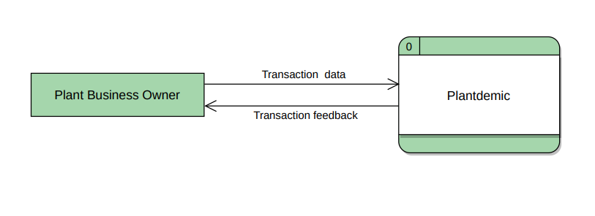**3.2.3 Context Diagram**

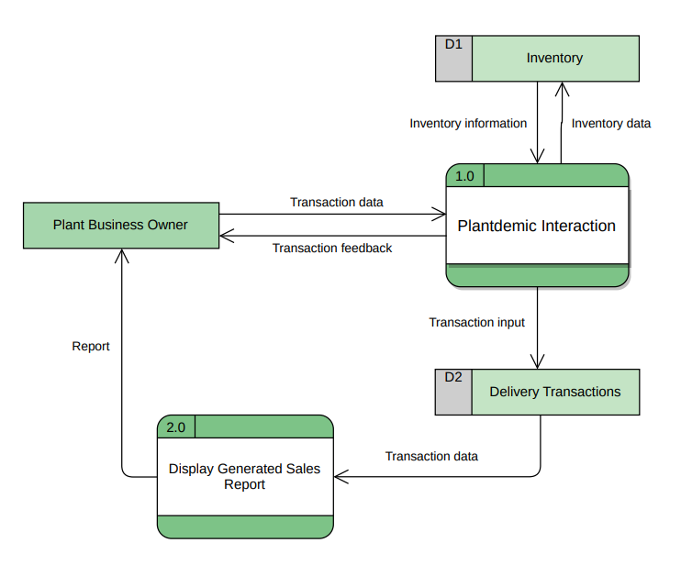**3.2.4 Diagram 0**

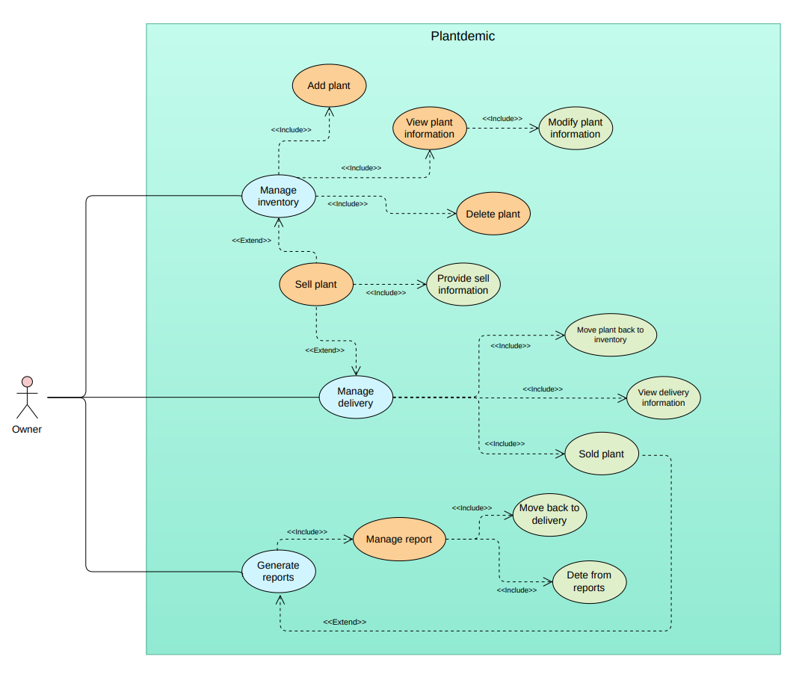**3.2.5 Use Case Diagram**

**3.2.6 Use Case Scenarios**

Add Plant to Inventory

| **Use Case Name** | Add Plant to Inventory | |
| --- | --- | --- |
| Summary: | Allows the user to add plants to inventory | |
| Actor: | Plant business owner | |
| Preconditions: | User must navigate to the add plant screen | |
| Postconditions: | The newly added plant will be displayed at the top of the list | |
| Basic Flow: | **Actor Action** | **System Response** |
| 1. User taps the floating action button | 1. System will display a new screen for adding plant |
| 1. User taps the camera icon to insert a photo of the plant | 1. System will display a dialog box that allows the user to choose whether to add a plant from the camera or gallery |
| 1. User successfully selected a photo for the plant | 1. System will display the selected photo overriding the default photo icon |
| 1. User taps the plant information fields | 1. System’s keyboard will open |
| 1. User inputs the plant information needed | 1. System will display the text input |
| 1. User presses the “Add plant” button | 1. System will display the added plant in the inventory in a form of list tile view |
|  | 1. User taps the “Back” button from the add plant screen | 1. System will display the inventory, without any changes |
| Exceptions: | * If the plant already exists in the inventory, a dialog box will appear and exit the add plant screen. The plant won’t be added in this case. * A restriction dialog box would display if user entered invalid inputs to the respective text fields, and if user will press the “Add plant” button with empty text fields. | |

Remove Plant from Inventory

| **Use Case Name** | Remove Plant from Inventory | |
| --- | --- | --- |
| Summary: | Allows the user to remove plants to inventory | |
| Actor: | Plant business owner | |
| Preconditions: | User must navigate to the inventory with plants already added. | |
| Postconditions: | The selected plant will be removed from the list | |
| Basic Flow: | **Actor Action** | **System Response** |
| 1. User slides the list tile of the specific plant from right to left | 1. System displays the delete icon button |
| 1. User taps the delete icon button | 1. System will display a confirmation dialog box asking the user if they really want to delete the plant |
|  | 1. User chooses to remove the plant   User chooses to cancel | 1. System removes the plant from the inventory and closes the dialog box.   System closes the dialog box without making any changes. |
| Exceptions: | The user can’t delete a plant that is not present in the inventory. | |

Search Inventory Plant

| **Use Case Name** | Search Inventory Plant | |
| --- | --- | --- |
| Summary: | Allows the user to search for a specific plant | |
| Actor: | Plant business owner | |
| Preconditions: | User must have tapped the search box | |
| Postconditions: | The searched plat will be displayed in accordance to user input | |
| Basic Flow: | **Actor Action** | **System Response** |
| 1. User taps the search box | 1. System will open the keyboard |
|  | 1. User searches for a plant | 1. System will display real-time matching character input |
|  | 1. User taps the exit button of the search box | 1. System will close the keyboard and display all plants in the inventory. |
| Exceptions: | If the searched plant is not present in the inventory, the system will display all plants in the inventory | |

Sort Inventory Plants

| **Use Case Name** | Sort Inventory Plants | |
| --- | --- | --- |
| Summary: | Allows the user to sort inventory plants by name, price, and quantity | |
| Actor: | Plant business owner | |
| Preconditions: | User must have a list of plants in the inventory | |
| Postconditions: | The list will be sorted based on the selected sort option | |
| Basic Flow: | **Actor Action** | **System Response** |
| 1. User taps the sort function | 1. System will display a sort option box with various sorting options to choose from |
|  | 1. User selects a sort option | 1. System will close the sort option box and sort the plants in the inventory based on the selected sort option |
| Exceptions: | If inventory is empty, no sorting will be performed | |

Edit Plant Information

| **Use Case Name** | Edit Plant Information | |
| --- | --- | --- |
| Summary: | Allows user to modify plant information | |
| Actor: | Plant business owner | |
| Preconditions: | User must navigate to the plant information screen | |
| Postconditions: | The changes will be observed in the plant tile information | |
| Basic Flow: | **Actor Action** | **System Response** |
| 1. User taps the list tile of a specific plant. | 1. System will push a screen showing its detailed information. |
| 1. User slides the information tile of the plant from right to left | 1. System displays the edit icon button |
| 1. User presses the “Edit” button | 1. System will display a dialog box containing the current plant information |
| 1. User taps the “Clear all” text button | 1. System clears all the text information fields |
| 1. User taps the text fields, and modifies information | 1. System displays the changed inputs real-time. |
| 1. User taps the “Cancel” button   User taps the “Save” button | 1. System pops the dialog box without changes.   Once saved, the system will update the information and reflect the changes made. |
|  | 1. User presses “Back” button from the detailed information of a plant. | 1. System will display the inventory screen, without any modifications made. |
| Exceptions: | A restriction dialog box will be displayed if:   * user entered invalid inputs to the respective text fields, * user will press the “Save” button with empty text fields, and * user modifies the name of the plant to a name that is already present in the inventory. | |

Provide Selling Information

| **Use Case Name** | Provide Selling Information | |
| --- | --- | --- |
| Summary: | Enables the user to sell a plant | |
| Actor: | Plant business owner | |
| Preconditions: | User must select a plant to sell | |
| Postconditions: | A confirmation dialog box will appear, providing feedback to the user that the plant has been successfully added to the delivery. | |
| Basic Flow: | **Actor Action** | **System Response** |
| 1. User taps the edit trailing icon | 1. System will display a dialog box where the user can input selling information |
|  | 1. User taps the ‘Clear’ text button | 1. System will clear the text field |
|  | 1. User taps the ‘Save’ text button | 1. System will save the information and display it |
|  | 1. User taps the ‘Cancel’ text button | 1. System will close the dialog box without making any changes |
|  | 1. User taps the ‘Add to delivery’ button | 1. System will close the selling information screen and navigate back to the inventory. The quantity of the plant being added to the delivery will be decremented. A pop-up box will be displayed, providing feedback to the user that the plant was successfully added to the delivery. |
| Exceptions: | A restriction dialog box will be displayed upon pressing the ‘Add to delivery’ button if:   * the user enters invalid inputs in the respective text fields, * the user selects a date that is not within the current week, and * the user presses the ‘Add to delivery’ button with empty required text fields | |

Manage Plant Delivery

| **Use Case Name** | Manage Plant Delivery | |
| --- | --- | --- |
| Summary: | Enables the user to review and manage the delivery information | |
| Actor: | Plant business owner | |
| Preconditions: | User has already added plants to the delivery | |
| Postconditions: | Once the user successfully sold a plant, a confirmation dialog box will appear | |
| Basic Flow: | **Actor Action** | **System Response** |
| 1. User taps the list tile of a specific plant | 1. System will navigate to a screen displaying the detailed information of the selected plant |
| 1. User presses “Sold” button | 1. System will close the current screen, remove the plant from the delivery, and display a pop-up box providing feedback that the plant was successfully added to the reports. The necessary information for generating reports will be recorded and stored in the system |
|  | 1. User presses “Back” button from the detailed information of a plant | 1. System will navigate back to the delivery screen without making any changes |
|  | 1. User slides the list tile and removes the plant from the delivery | 1. System will remove the selected plant from the delivery and increment the quantity of that plant back in the inventory. |
| Exceptions: | If there are no plants added to the delivery, the user will not be able to review or manage any plants in the delivery. The system displays a message informing the user that the delivery is empty. | |

Review Generated Reports

| **Use Case Name** | Review Generated Reports | |
| --- | --- | --- |
| Summary: | Enables the user to review analytics and statistics derived from previous transactions. | |
| Actors: | Plant business owner | |
| Preconditions: | Successful and recorded transactions have been made | |
| Postconditions: | Graph reports are displayed | |
| Basic Flow: | **Actor Action** | **System Response** |
| 1. User navigates to the reports section | 1. System displays the weekly profit summary of sold plants |
| 1. User taps the ‘Delete’ icon button by sliding the tile of a specific plant | 1. System will display a confirmation dialog box asking the user if they really want to remove the plant or move it back to delivery |
| 1. User chooses to remove the plant   User chooses to move the plant back to delivery | 1. System closes the dialog box and removes the plant from the reports. The graph is decremented accordingly.   System closes the dialog box and removes the plant from the reports, moving it back to the delivery. The graph is decremented accordingly. |
| Exceptions: | If there were no completed or successful transactions, no sales report will be displayed. | |

**3.3 Summary**

The proposed application aims to assist plant business owners in managing and tracking their plants and transactions. The application offers multiple use case scenarios, including:

1. "Add Plant to Inventory" allows the user to add plants to the inventory. The newly added plant will be displayed at the top of the list.
2. "Remove Plant from Inventory" enables the user to remove plants from the inventory. The selected plant will be removed from the list after confirming the deletion.
3. "Search Inventory Plant" allows the user to search for a specific plant in the inventory. The searched plant will be displayed based on the user's input.
4. "Sort Inventory Plants" enables the user to sort inventory plants by name, price, and quantity.
5. "Edit Plant Information" allows the user to modify plant information. The changes will update the plant tile information.
6. "Provide Selling Information" enables the user to sell a plant by providing the necessary selling information. A confirmation dialog box will appear after successfully adding the plant to the delivery.
7. "Manage Plant Delivery" allows the user to review and manage the delivery information. The user can mark a plant as sold or remove it from the delivery.
8. "Review Generated Reports" enables the user to review analytics and statistics derived from previous transactions. Graph reports are displayed, and the user can choose to remove a plant from the reports or move it back to the delivery.

These use cases provide a comprehensive set of functionalities to efficiently manage plant inventory, sales, and generate valuable insights for the plant business owner.

**Chapter 4 PERFORMANCE ANALYSIS**

**4.1 Introduction**

The application has undergone functional and non-functional testing as performed by the developer, testers, the instructor, and panelists. The areas that were observed, validated, and tested are the requirements and the additional features.

The minimum requirements are the functionalities that make the application practical and usable. These are the workflows that must be undergone to simulate the complete stakeholders’ flowchart. The additional features are what makes the application unique. The additional features are not found in the stakeholders’ flowchart but are implemented because it is beneficial to its end-users. The application aims to assist plant business owners in managing their plants and transactions efficiently.

**4.2 Experimental**

The “one-cycle” was carefully followed to test whether the requirements were met. The testing process involved sequentially going through the different use cases of the app, each contributing to the overall flow and functionality of the system.

The first step was to add plants to the inventory. This allows the user to input plant details, and the newly added plants would appear at the top of the inventory list, ensuring easy access and organization.

Next, the removing of plants allows the user to selectively remove plants from the inventory. By sliding the list tile of a specific plant and confirming the deletion, the selected plant would be removed from the list, maintaining an updated inventory.

Then, user can enter search queries and find specific plants in the inventory. The app displays real-time matching results based on the user's input, simplifying the process of finding desired plants.

The sort functionality enables the user to sort the inventory plants based on different criteria such as name, price, and quantity. This feature provided flexibility in organizing and viewing the inventory based on the user's preferences.

The app also allows the user to modify plant details. By tapping on a plant's list tile and accessing the plant's detailed information, the user could make changes and update the plant tile information accordingly.

To sell plants, the user could input the necessary selling information, such as price and quantity, and add the plant to the delivery. After successful addition, a confirmation dialog box would appear, providing feedback that the plant had been added to the delivery.

Managing plant delivery was made possible in the delivery section. The user could review and manage the delivery information, marking plants as sold or removing them from the delivery as needed. This allows for efficient tracking and organization of outgoing plants.

Finally, reviewing sales report feature provides the user with analytics and statistics derived from previous transactions. By accessing the reports section, the user could view graph reports, such as the weekly profit summary of sold plants. Additionally, the user had the option to remove a plant from the reports or move it back to the delivery, providing flexibility in managing and analyzing the generated reports.

By sequentially going through these use cases, the app's flow and functionality were thoroughly tested, ensuring that all requirements were met and providing a comprehensive tool for plant business owners.

The additional features were also tested whether it is functional. This feature is located in the reports section of the app, allowing users to view a comprehensive summary report. The report includes a calendar displaying dates, with a dot indicator representing successful transactions on specific days. The inclusion of this additional feature enhances the overall functionality of the app by providing users with a visual representation of transaction activity over time. It aids in tracking sales trends relevant and useful for plant business owners.

**4.3 Result and Analysis**

The application was able to perform the requirements and additional features which state that it is functional and usable.

**4.4 Summary**

The application was able to perform all the requirements which state that it is functional and usable. It provides plant business owners with an efficient and comprehensive tool for managing their plants and transactions. The testing process, coupled with the inclusion of additional features, ensures a user-friendly application that caters to the specific needs of plant business owners.

**Chapter 5 CONCLUSION**

Based on the results and analysis, it can be concluded that the application has met all the specified requirements. The proposed "Plantdemic" app has successfully addressed the needs of plant business owners by providing a tool that is simple and user-friendly for managing plants and business transactions. Throughout this paper, the project specifications, including hardware and software requirements, use-case scenarios, and system design, were outlined to establish a clear understanding of the app's functionality.

The testing process, which included both functional and non-functional testing, played a crucial role in ensuring the app's reliability and usability. By following the "one-cycle" approach, various use cases were thoroughly tested, covering essential functionalities such as adding and removing plants, searching and sorting inventory, modifying plant details, managing plant deliveries, and reviewing sales reports. Additionally, the inclusion of additional features, such as the comprehensive summary report and transaction activity calendar, further enhanced the app's functionality and provided valuable insights for plant business owners.

To ensure the application keeps pace with the evolving needs of plant business owners, future improvements and enhancements can be explored. These endeavors would focus on scaling the application's capabilities to accommodate growing demands. Furthermore, incorporating additional features based on user feedback and industry trends could be considered, alongside optimizing the app's performance to handle larger datasets. Additionally, exploring opportunities for integration with other relevant systems or platforms would further streamline operations for plant business owners.

Overall, the development and testing of the "Plantdemic" app have successfully demonstrated its value in assisting plant business owners in managing their businesses effectively. With its user-friendly interface, comprehensive functionality, and potential for future enhancements, the "Plantdemic" app holds great promise for the plant industry, contributing to the growth and success of plant businesses in the digital era.

**BIBLIOGRAPHY**

Aratani, Lauren. 2021. “Gardening Trend That Bloomed during the Pandemic Is Here to Stay.” *The Guardian*, March 31. https://www.theguardian.com/lifeandstyle/2021/mar/31/gardening-trend-pandemic-here-to-stay.

Bajenting, Johanna O. 2020. “Plant, Pottery Businesses Boom.” *SUNSTAR*, July 6. https://www.sunstar.com.ph/article/1862547/cebu/business/plant-pottery-businesses-boom.

Carleton, Audrey. 2021. “The Covid-19 Houseplant Boom: Why Monsteras Are Dominating Social Media.” *Vox*, August 16. https://www.vox.com/22611799/houseplants-environmental-impact-youtube.

Dove, Jackie. 2022. “The Best Gardening Apps for 2022.” *Digital Trends*, May. https://www.digitaltrends.com/mobile/best-gardening-apps/.

“Flowers and Ornamental Plants Market Scope, Size & Global Trends By 2029.” 2023. *Data Bridge Market Research, Https://Www.Databridgemarketresearch.Com, All Right Reserved 2023*. Accessed April 20. https://www.databridgemarketresearch.com/reports/global-flowers-and-ornamental-plants-market.

Research, Industry. 2022. “Global Flower and Ornamental Plants Market Outlook to [2022-2027] | Growing at a CAGR of 6.3% with Business Strategies, Emerging Demands, Industry Share, Growth Rate, Recent Trends, Opportunity, and Forecast to 2027.” *GlobeNewswire News Room*, February 19. https://www.globenewswire.com/news-release/2022/02/19/2388247/0/en/Global-Flower-and-Ornamental-Plants-Market-Outlook-to-2022-2027-Growing-at-a-CAGR-of-6-3-with-Business-Strategies-Emerging-Demands-Industry-Share-Growth-Rate-Recent-Trends-Opportun.html.

Stevens, Courtenay. 2023. “The Best Inventory Apps of 2023.” *Business.Org*. May 16. https://www.business.org/finance/inventory-management/best-inventory-apps/.

Sunga, Archie, and Jowie Lumanog Advincula. 2021. “The ‘Plantito/Plantita’ Home Gardening during the Pandemic.” *Community Psychology in Global Perspective* 7 (1): 88–105. doi:10.1285/i24212113v7i1p88.

Vincent, Sarah. 2023. “6 Best Plant-Care Apps to Download for All Your Plant Needs.” *Reader’s Digest*. January 12. https://www.rd.com/list/best-plant-care-app/.

**ACKNOWLEDGEMENT**

First and foremost, I am profoundly grateful to **God, the Almighty**, for bestowing upon me the necessary abilities and knowledge that sustained and enabled the success of this project.

This project would not have reached its completion without the invaluable assistance, guidance, and efforts of numerous individuals. I would like to express my deepest gratitude to the following individuals:

I extend my heartfelt appreciation to my beloved **parents** for their considerate support, both financially and morally. Their unwavering encouragement and understanding, along with their respect for my work on the app, have been invaluable. I am especially thankful to my **mother**, whose hobby and plant business served as the inspiration behind the development of this app. Her continuous support and collaboration throughout the development process are highly appreciated, from selecting colors, text layout, shapes, and images, to establishing the overall mood of the app.

My sincere gratitude also goes to our course instructor, **Mr. Rodney Milleza Maniego Jr.**, who has consistently provided encouragement and essential guidance throughout the application development process. His valuable insights, constructive feedback, and expert advice have played a crucial role at every stage of our applications.

Furthermore, I would like to acknowledge my **classmates** for their responsiveness to my inquiries regarding my app's user interface, and for allowing me to deploy and test the app on their phones.

I would also like to express my deepest appreciation to my **closest friend**, who has been a pillar of support throughout this journey. Her unending emotional support and encouragement have been instrumental in keeping me motivated, especially during moments of frustration and struggle related to the app.

Lastly, I would like to acknowledge my own perseverance in overcoming the challenges faced during the development of the app. I commend myself for the countless hours of hard work, including late nights and sacrificing sleep, to meet the rigorous requirements of the project. Despite the hurdles, I remained steadfast and committed, never losing interest and motivation to continue the development process. This personal commitment has been vital in pushing through difficulties and ensuring progress.

**APPENDICES**

**Plantdemic** **User Manual**

1. Installation
2. Features
3. Add plant to inventory
4. Sort inventory plants
5. Remove plant from inventory
6. Search inventory plants
7. Modify plant details
8. Manage plant deliveries
9. Review sales report
10. Glossary

**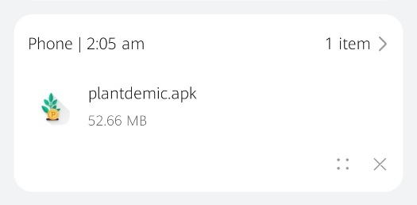****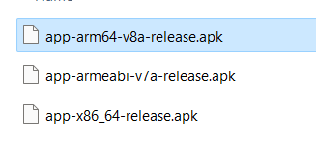I. Installation**

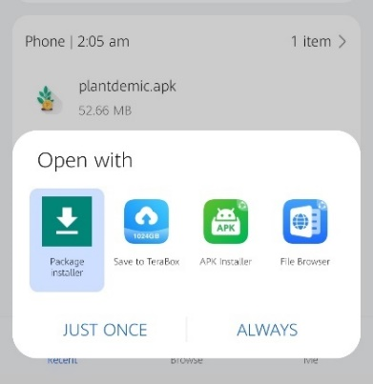

Have an apk file of the application. Since ARM is the most common architecture used in Android smartphones, either app-arm64-v8a-release or app-armeabi-v7a-release would be the most commonly used APK file.

Install the app and wait for the installation process to complete.

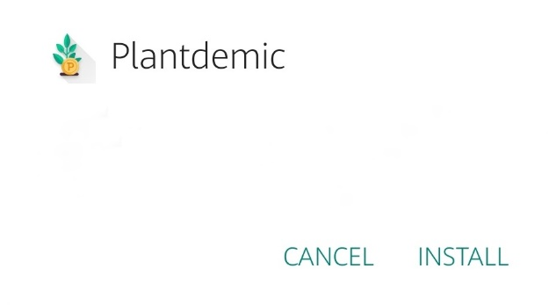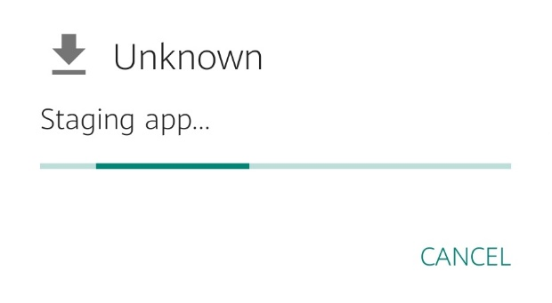

**II. Features**

1. Add plant to invetory

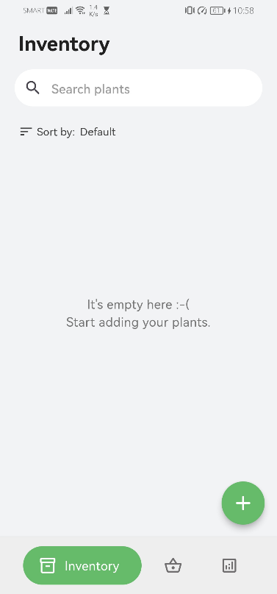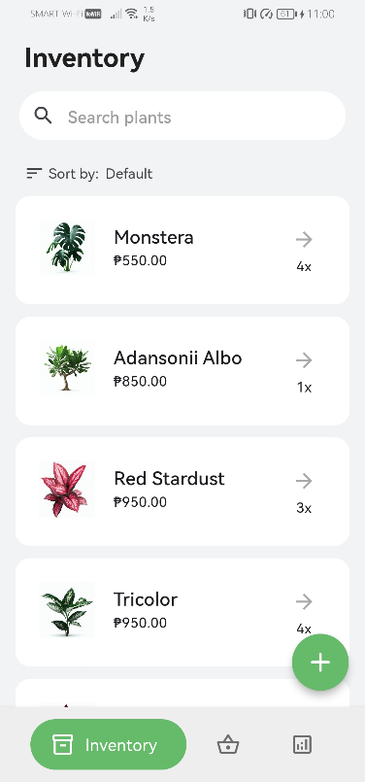

Empty inventory

Added inventory plants

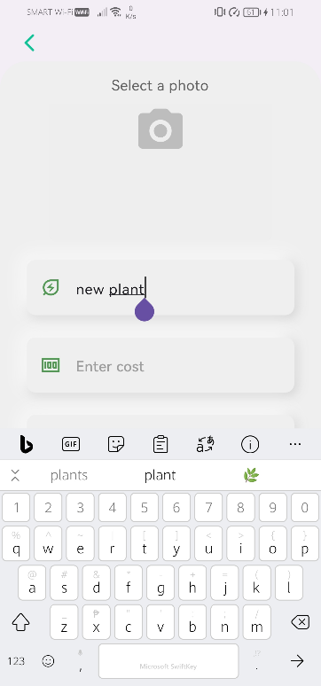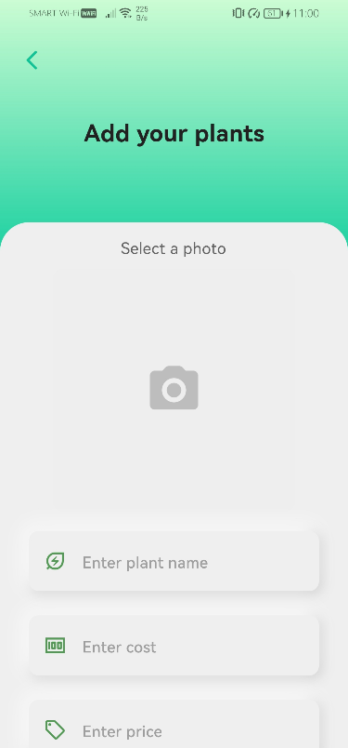





Enter the plant information into the designated text fields.

Tap the floating action button, which is represented by the plus '+' icon located at the bottom right corner of the inventory screen.

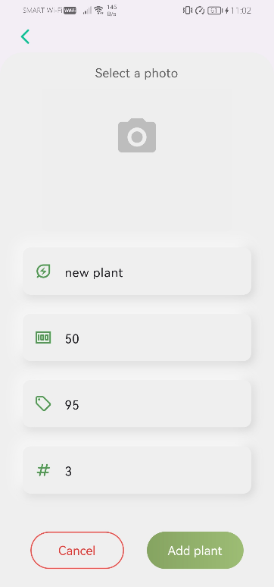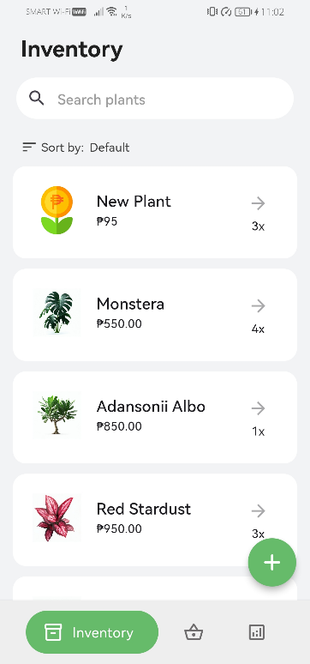

After pressing the 'add plant' button, the newly added plant will be displayed at the top of the list.

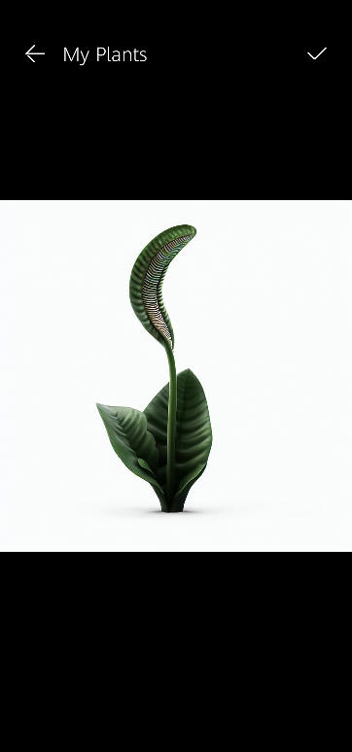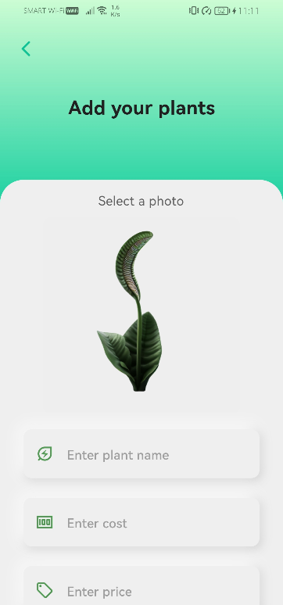

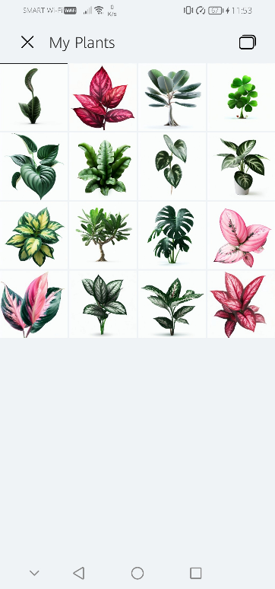

There are two options to add an image: either by using the camera or by browsing the gallery.

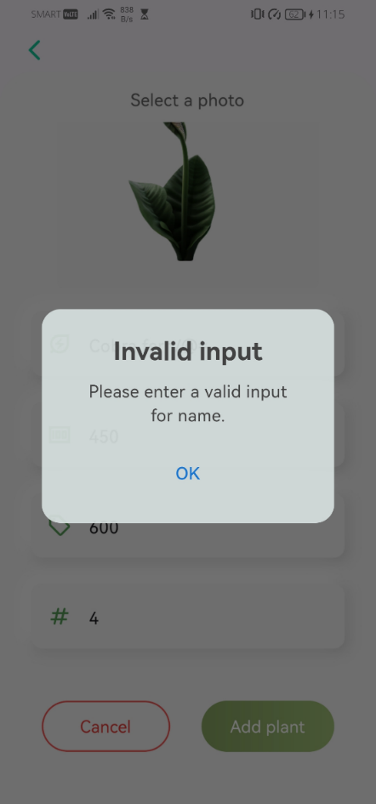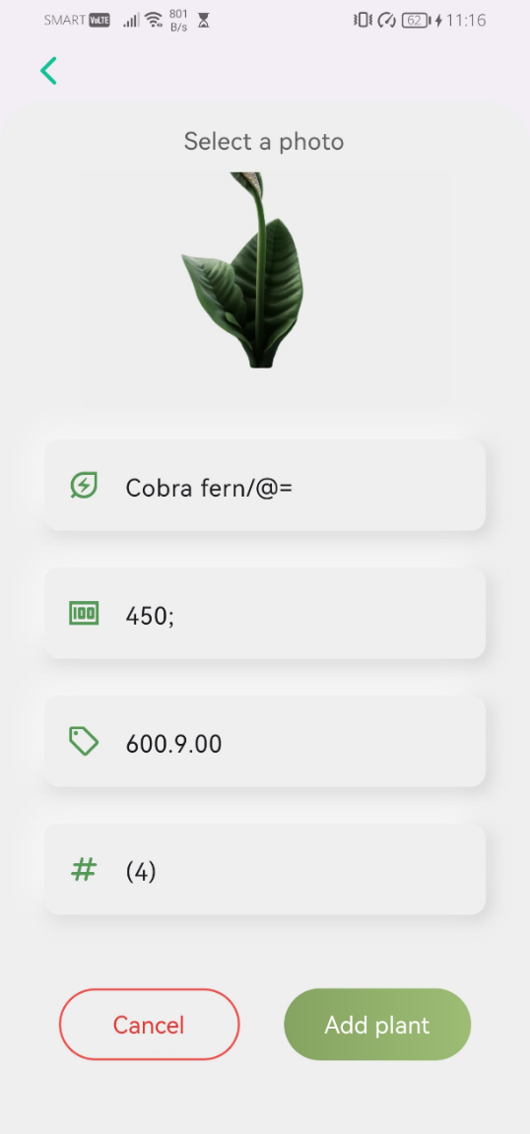

Validate the inputs of the plant name.

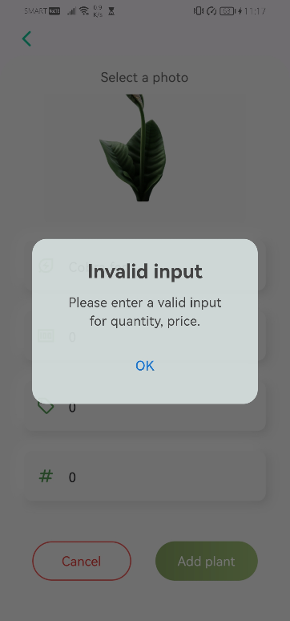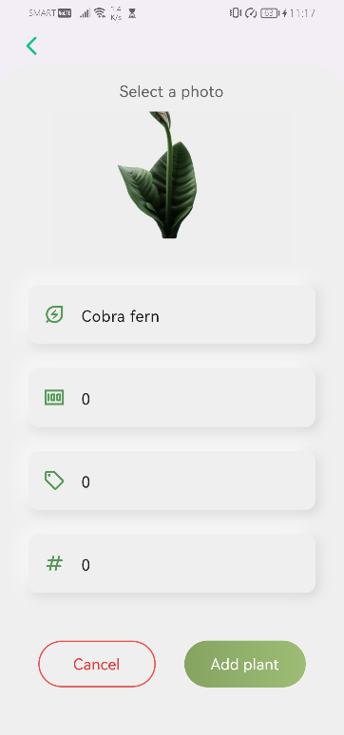

Validate the inputs. Ensure that the price and quantity fields are not zero. However, the cost field may be zero if the user is selling plants they have grown in their garden instead of purchasing them.

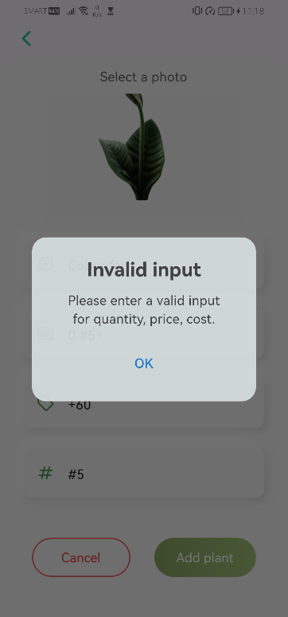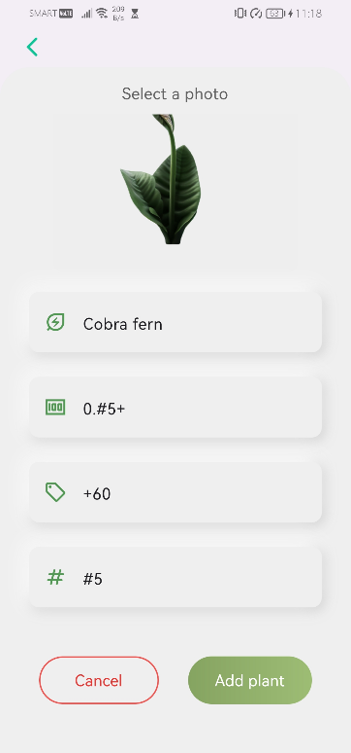

Ensuring that all inputs are valid.

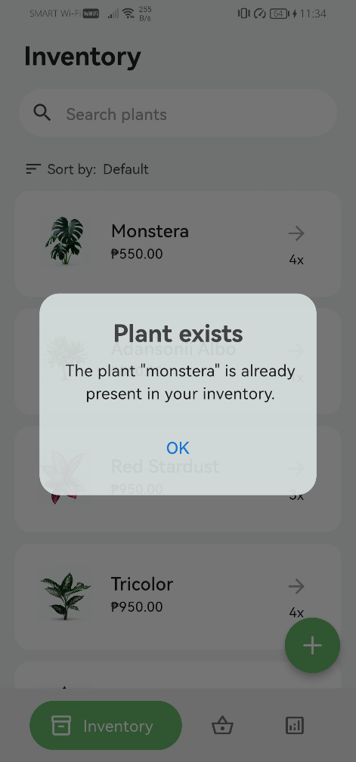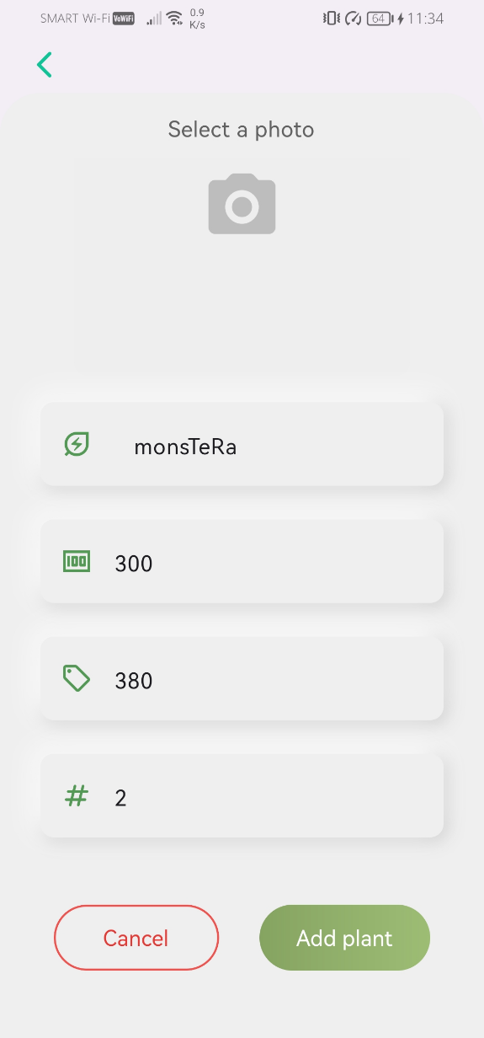

Addition is invalidated if a plant with the same name is already present in the inventory.

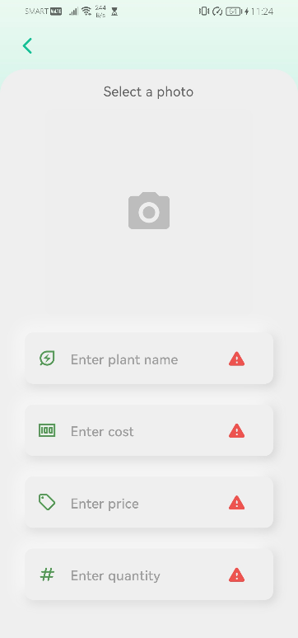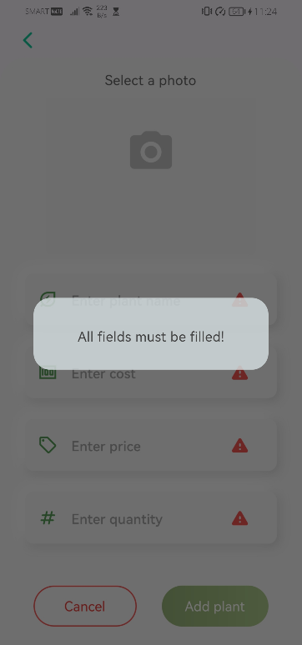

To ensure there are no empty text fields, please fill in all the required information.

1. Sort inventory plants

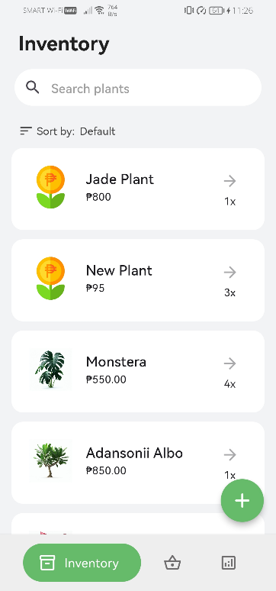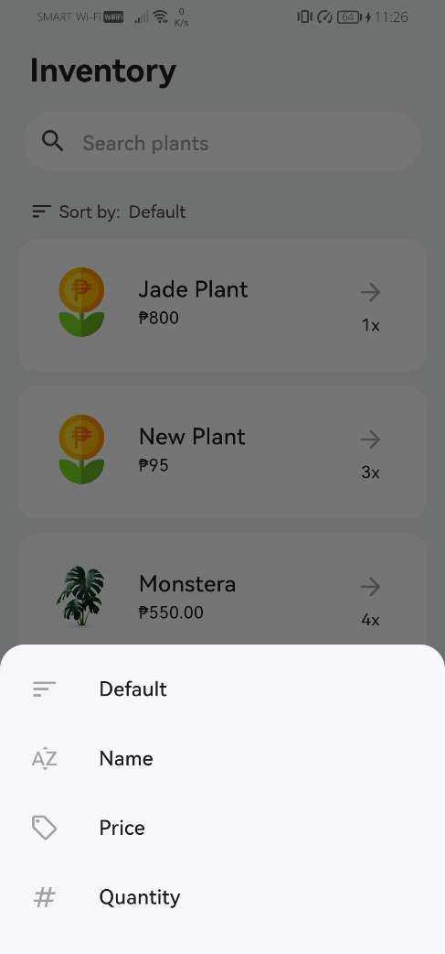



To sort plants in the inventory, tap the sort function first then select a sorting option in the sorting menu. This will arrange the plants based on the selected sorting criterion.

1. 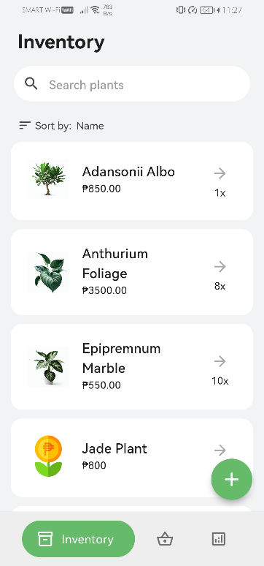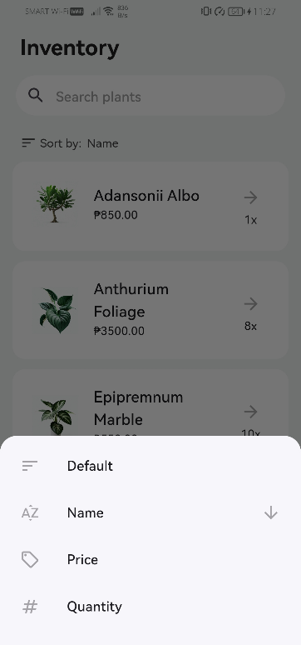Sort by name

Plants are sorted by name in alphabetical order

1. 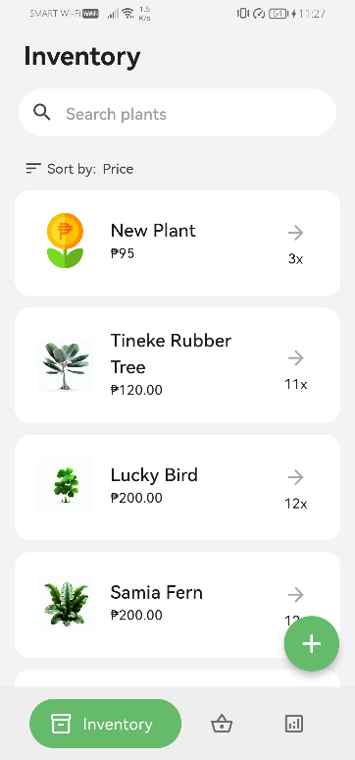Sort by price

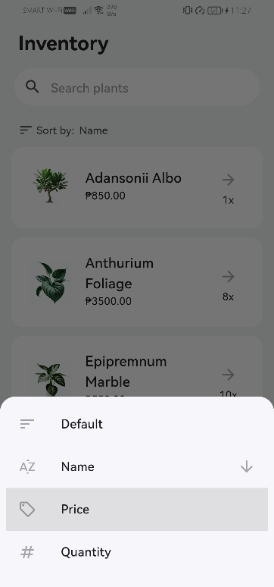

Plants are sorted by price in ascending order

1. 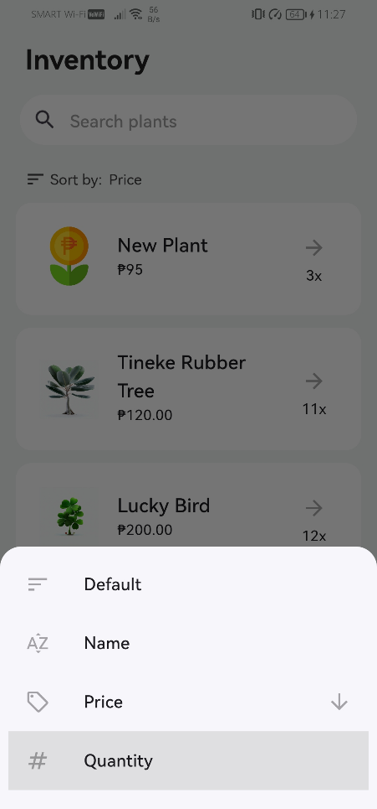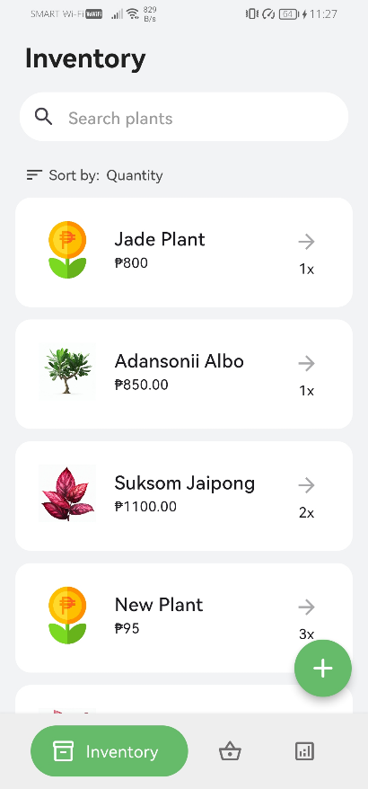Sort by quantity

Plants are sorted by price in ascending order

1. 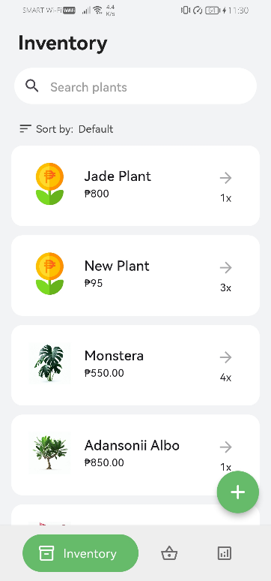Default

Restarting the application will reset the sorting option to its default setting. This means that newly added plants will be placed at the top of the list.

1. Remove plant from inventory

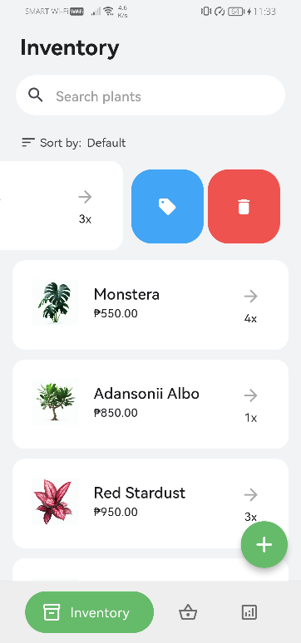



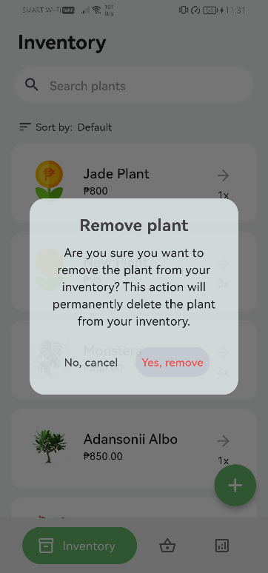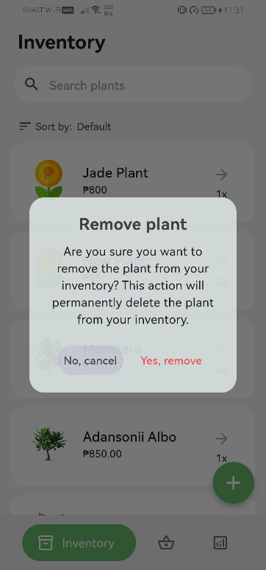

When removing a plant, a dialog box will be displayed, asking the user to confirm the removal of the plant from the inventory.

1. Search inventory plants

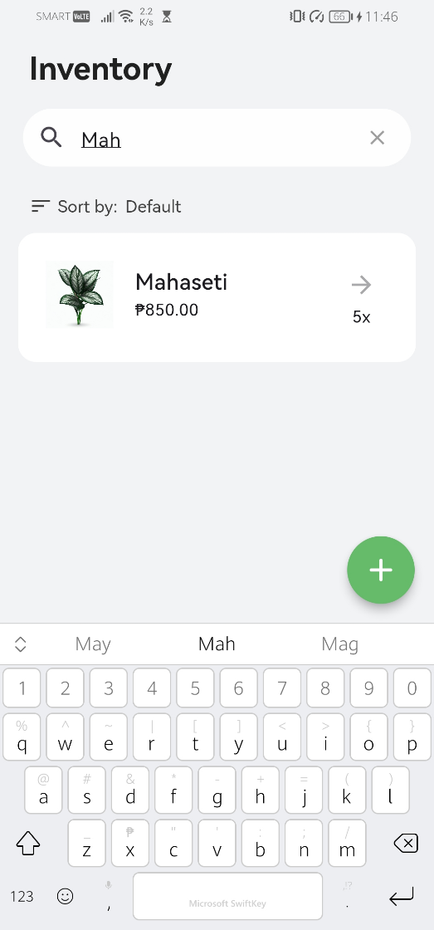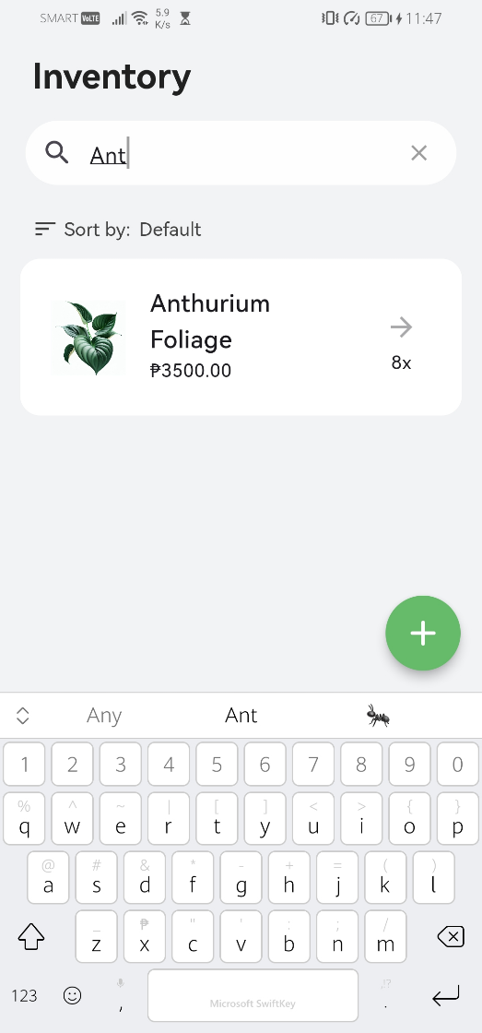

To search for a specific plant, simply tap the search box.

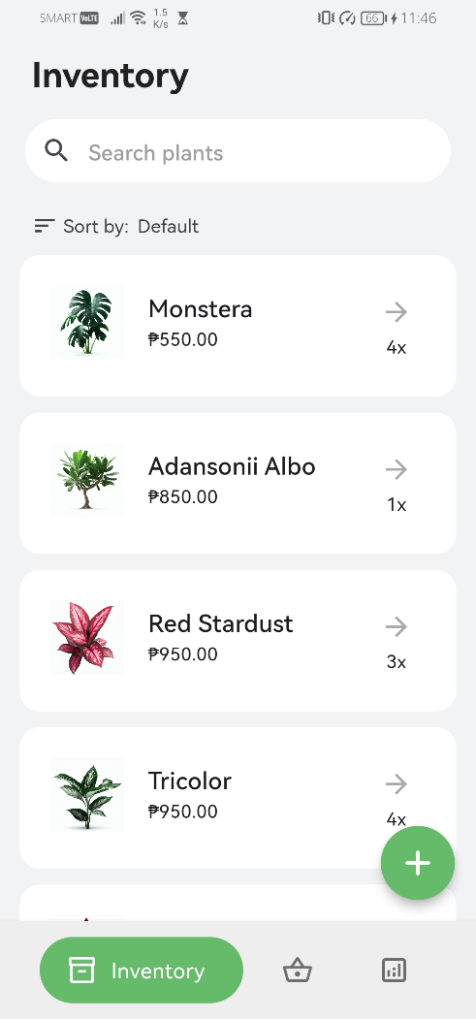

Tapping the 'exit' icon will display all the plants in the inventory.



1. Modify plant details

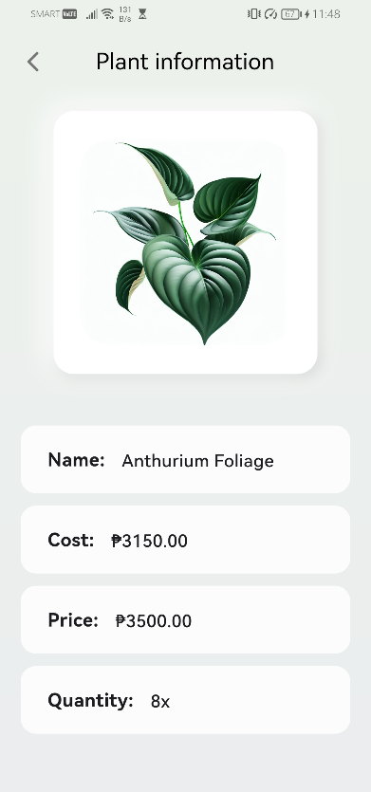

From the inventory, tap on the plant tile to view or modify all the information of that plant.

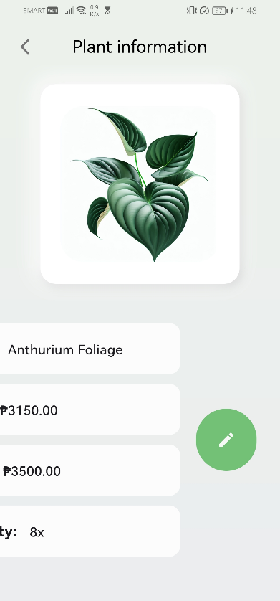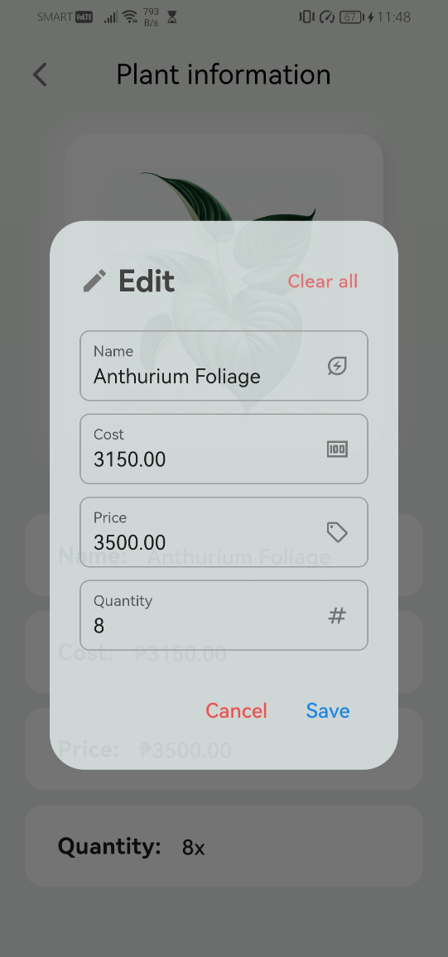

To edit the information of a plant, slide the information tile and then tap the edit icon.

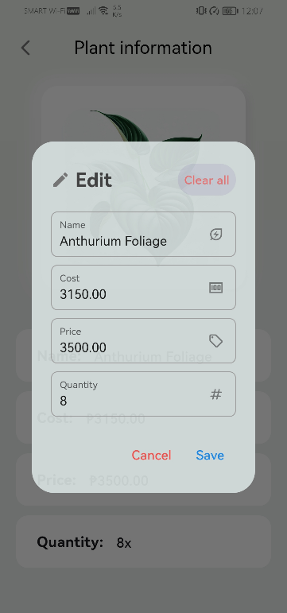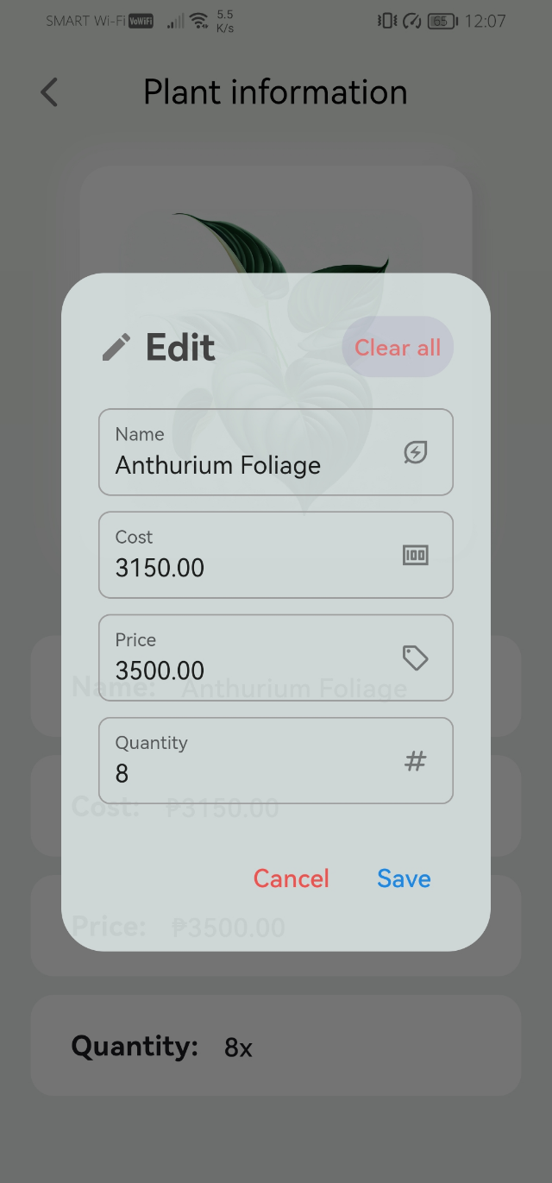

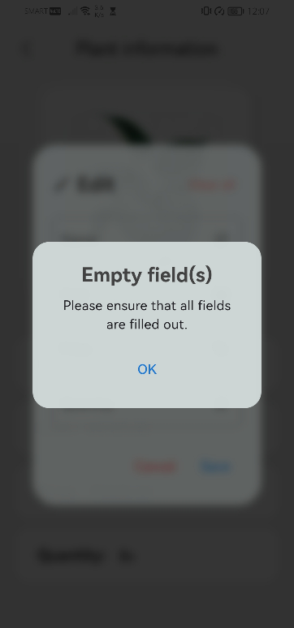

Clearing the plant information and attempting to save it is not allowed.

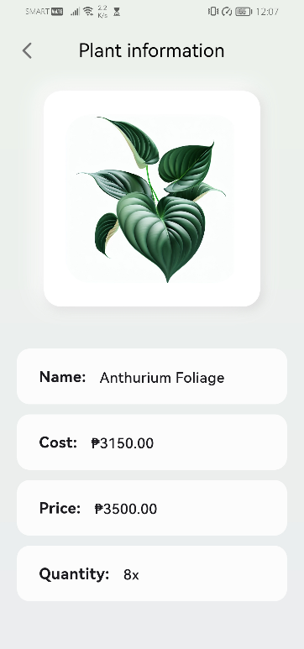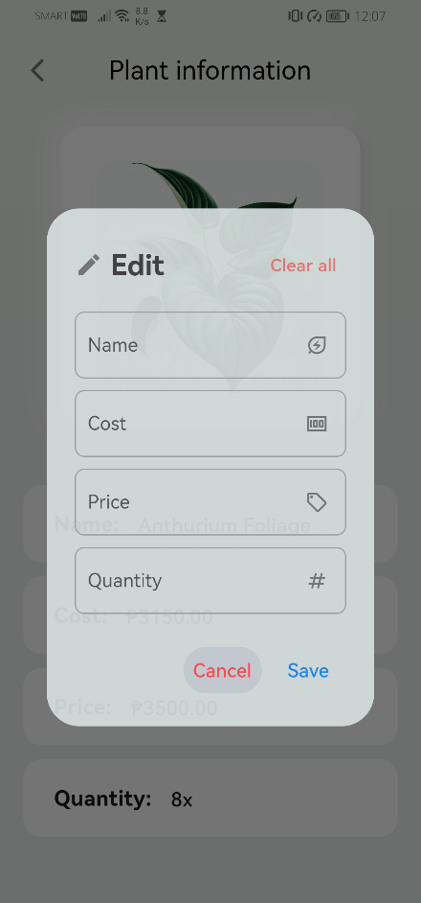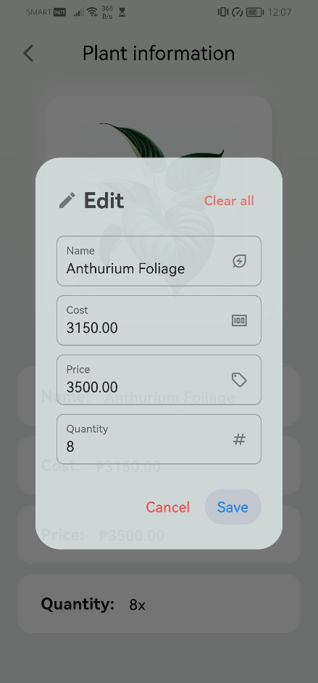

Tapping the ‘clear all’ text button then cancel it closes the edit dialog box without making any changes. The same is true when tapping directly the save button after clearing the fields.

Similar to when adding plants, there are also restrictions when modifying the plant information.

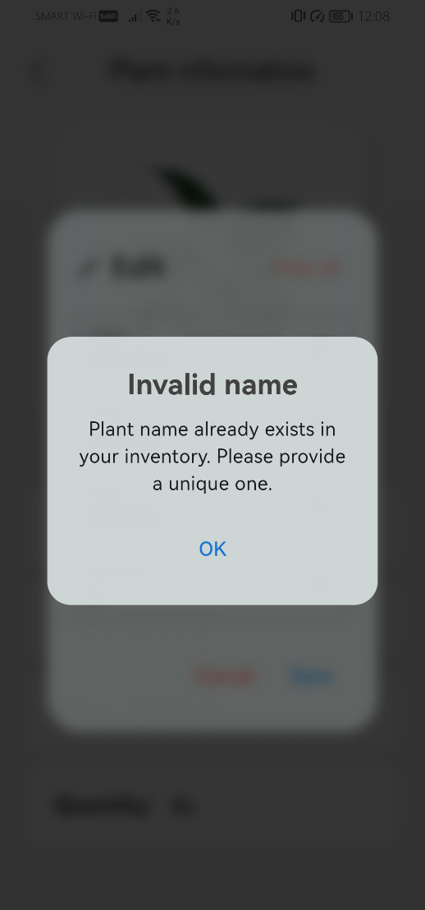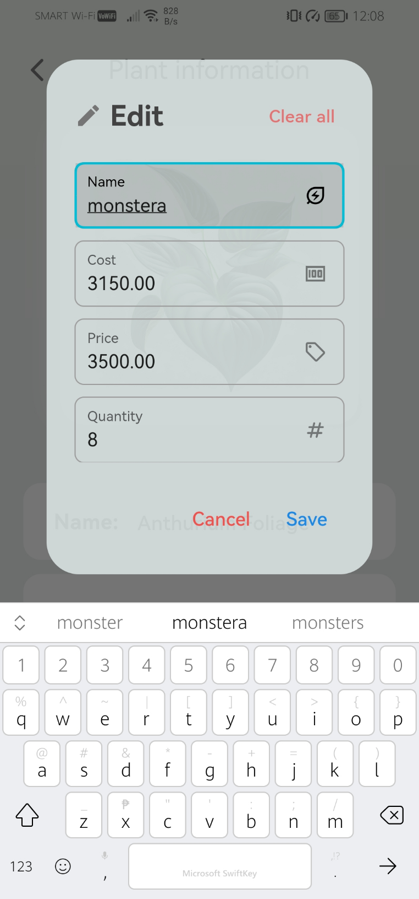

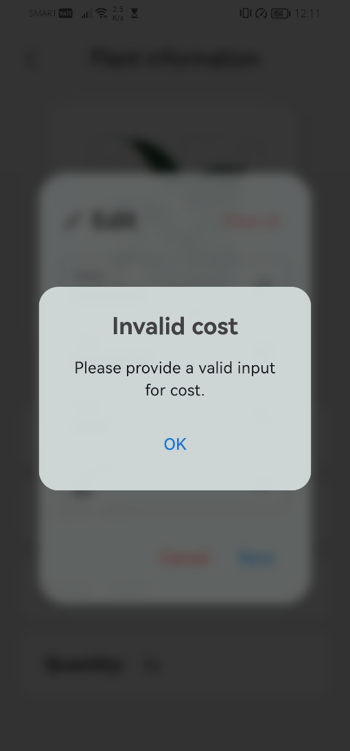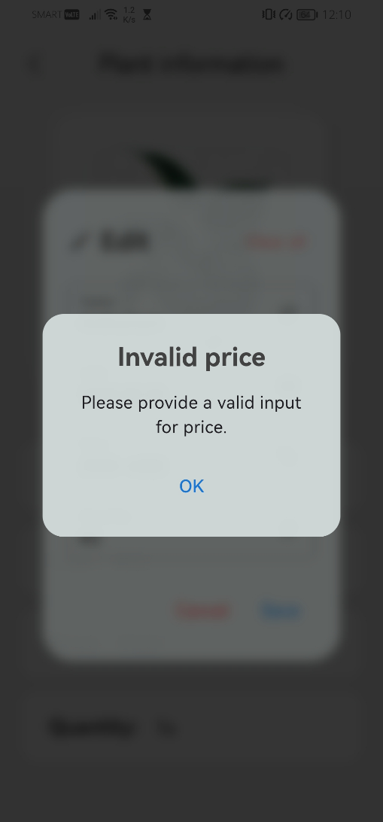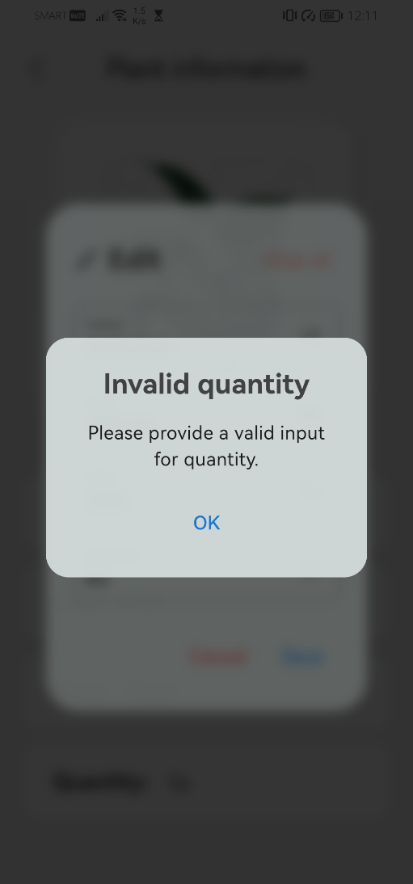



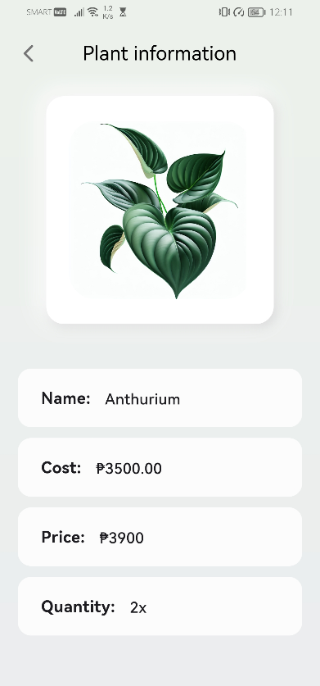

A valid and successful modification will update the plant information.

1. Manage plant deliveries

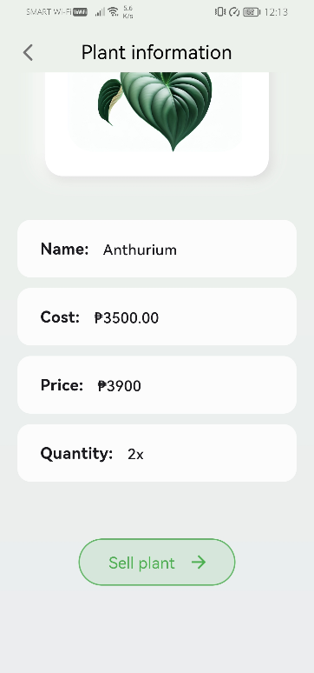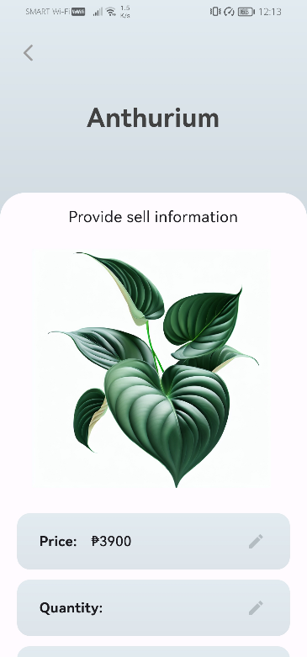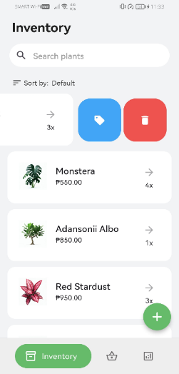

Scrolling to the bottom and tapping the 'sell Plant' button will navigate to a new screen. The same happens when sliding the plant tile and pressing the 'sell' icon button.

When selling a plant, certain restrictions are in place to handle invalid inputs.

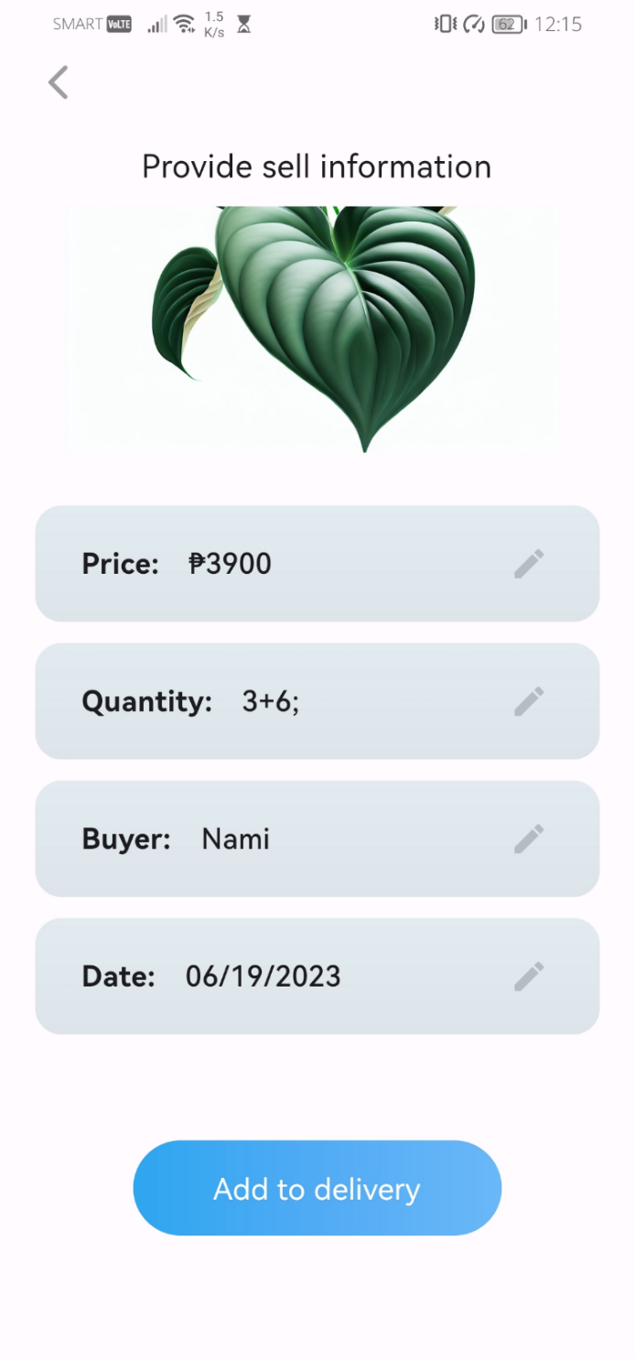

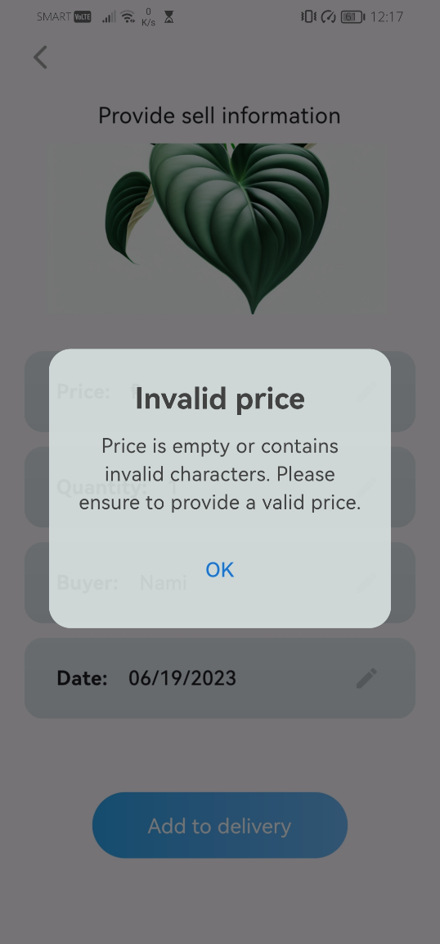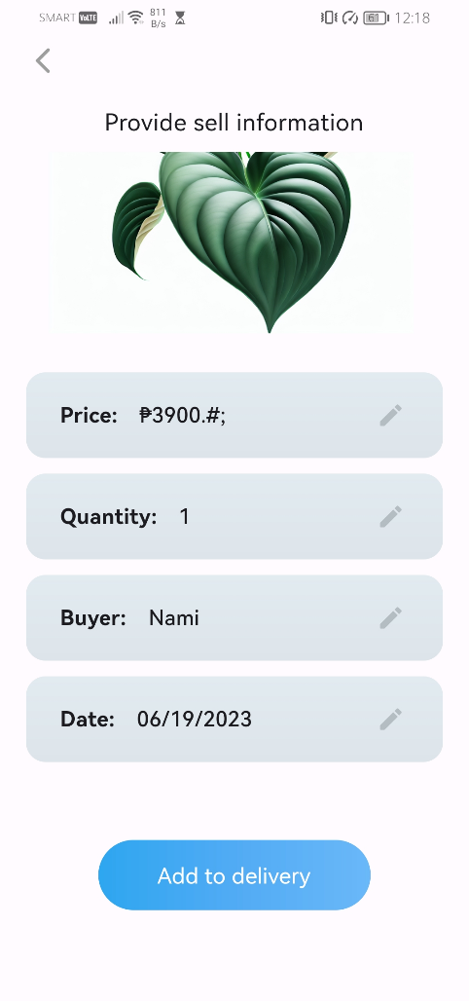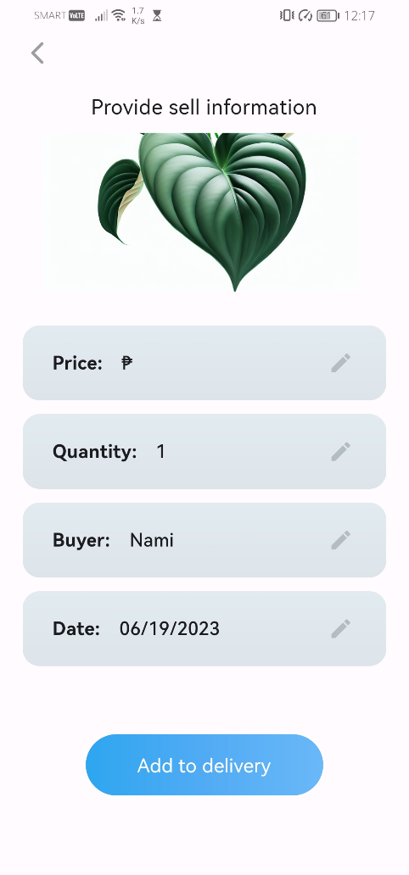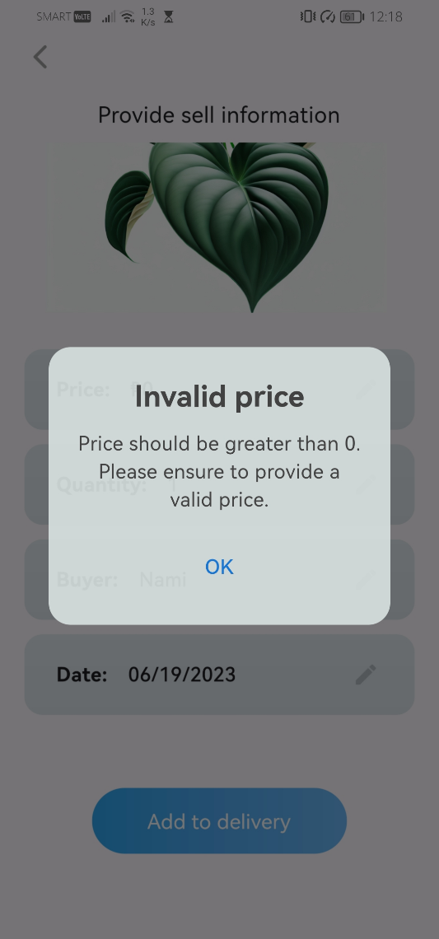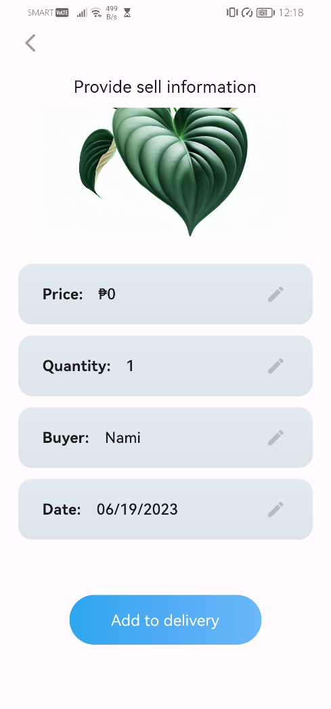

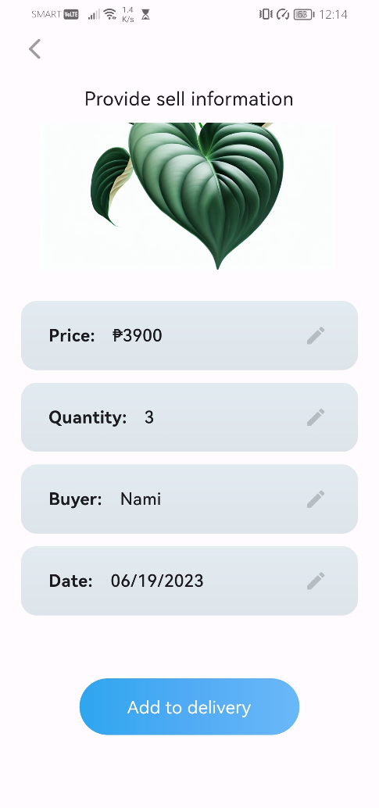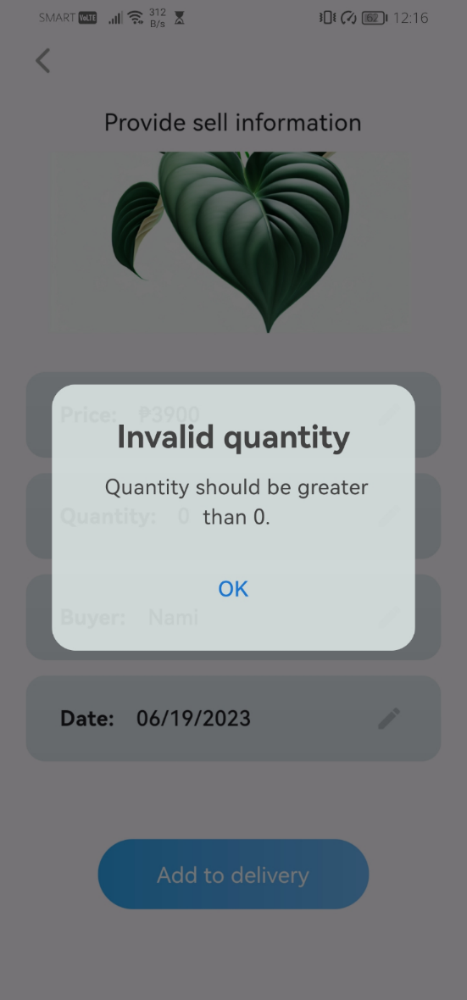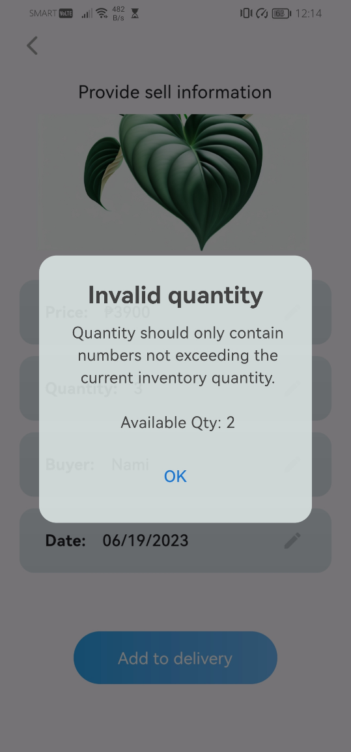

Selling a plant is not allowed if the requested quantity exceeds the current inventory quantity.

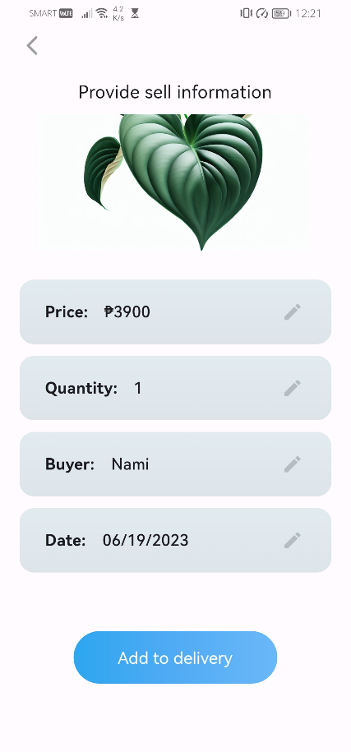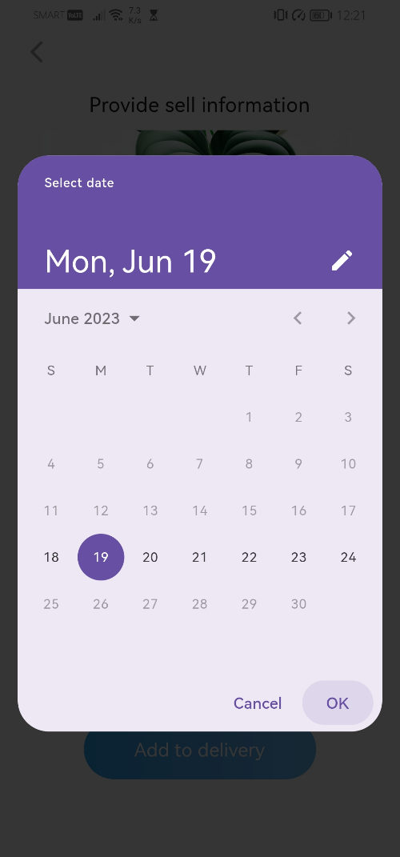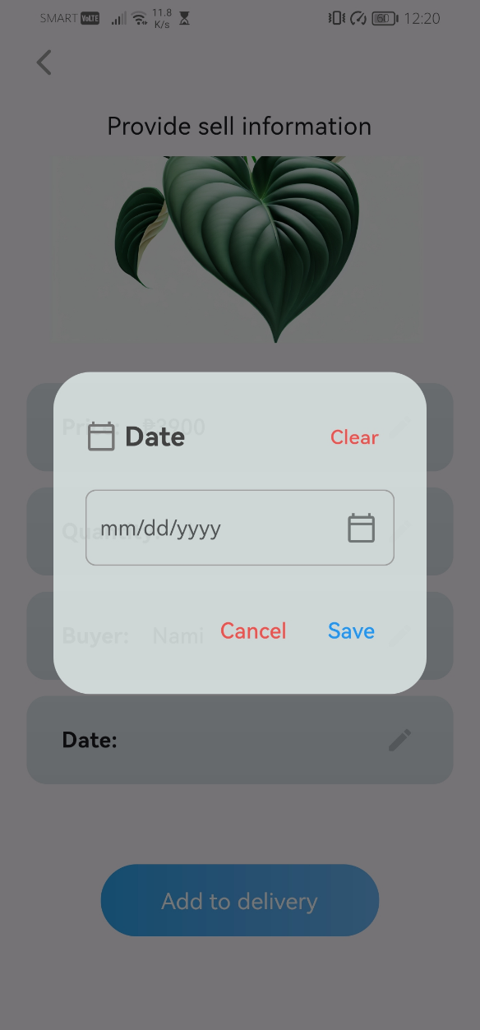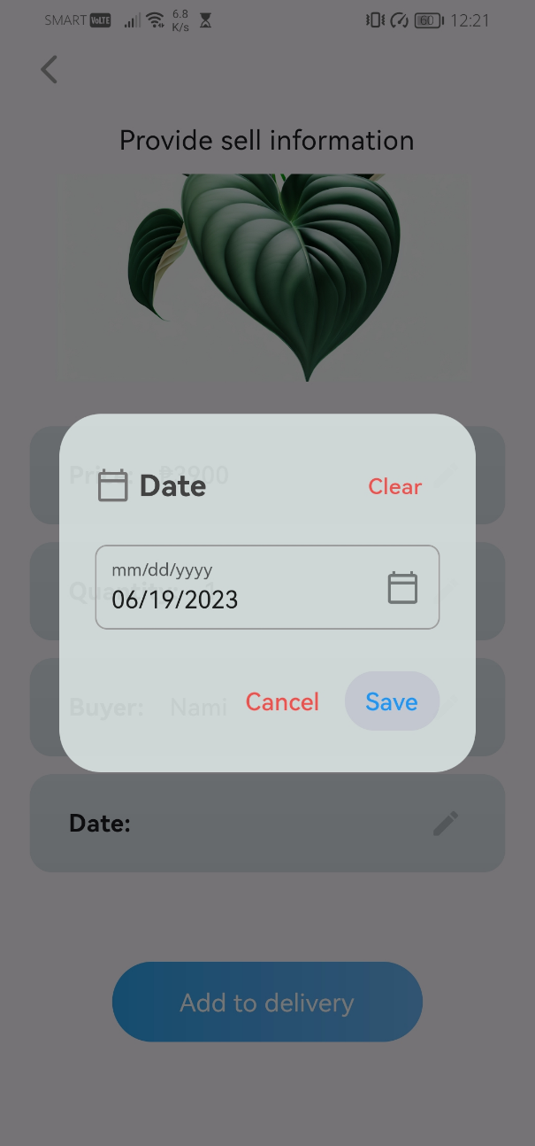

Setting a valid delivery date.

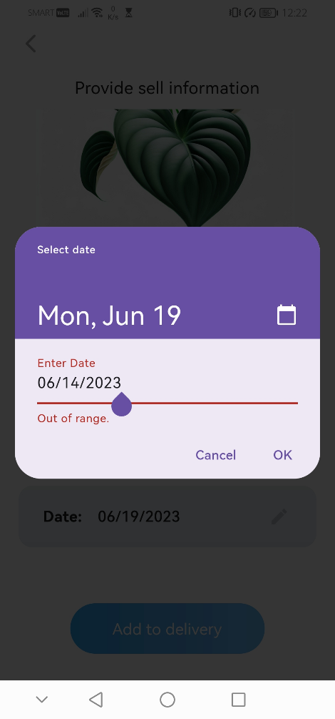

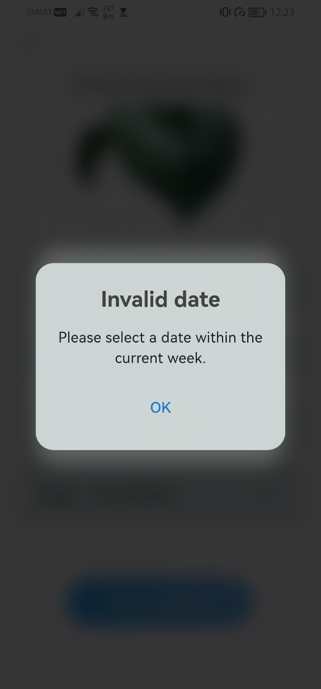

The delivery date must be within the current week.

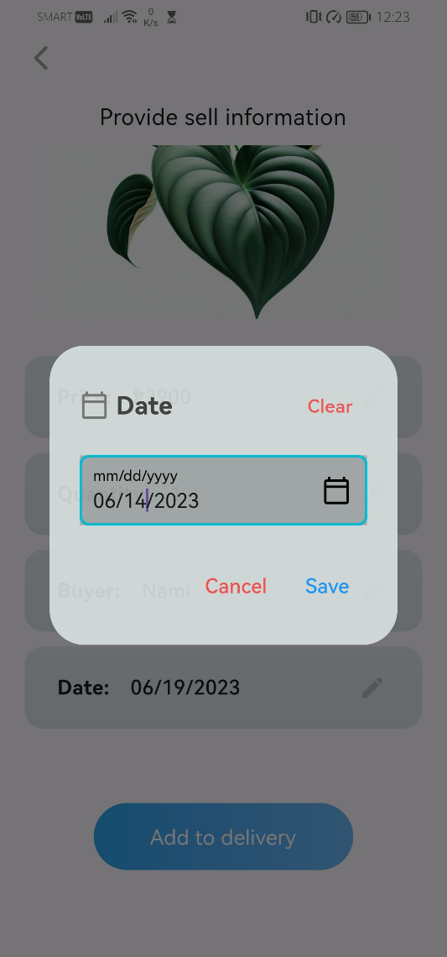

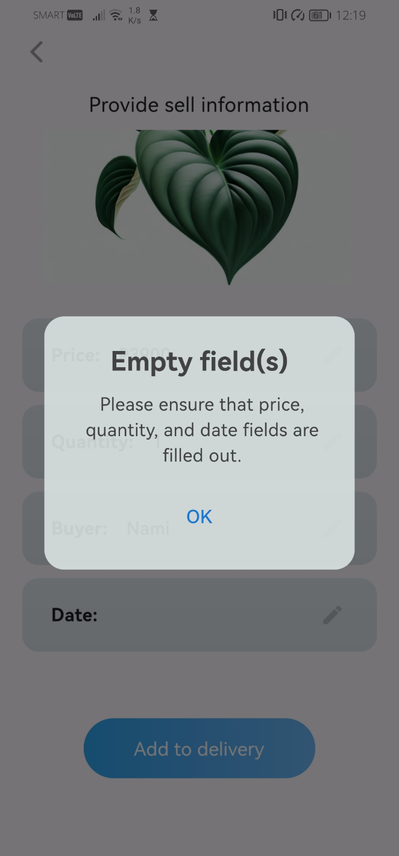

All required fields must be filled before adding the plant to the delivery.

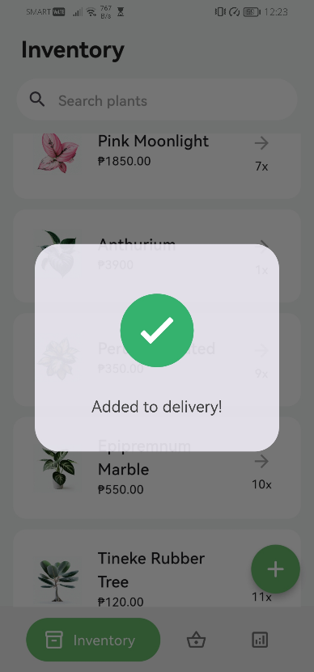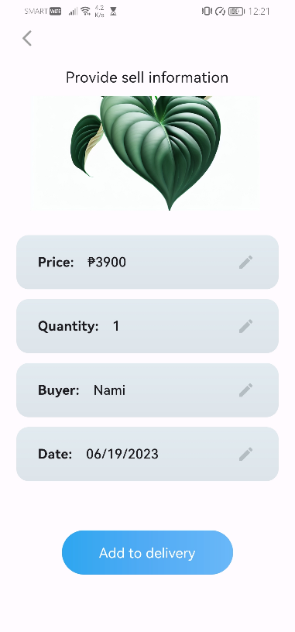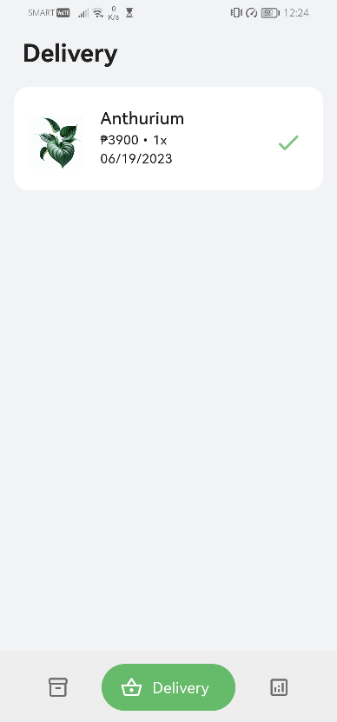

A dialog will be displayed to provide feedback confirming that the plant has been successfully added to the delivery.

Once everything is set, you can now add the plant to the delivery.

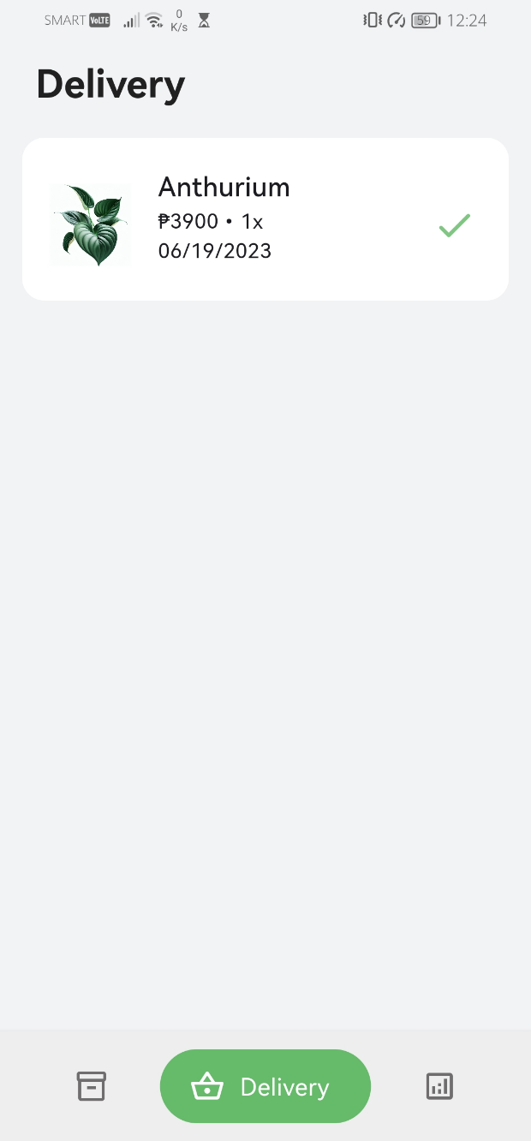

Tapping the ‘check’ icon button adds the plant to the sales reports section

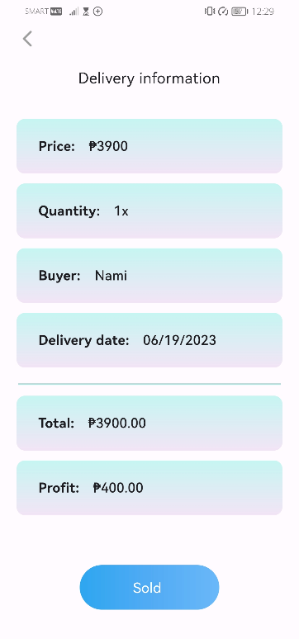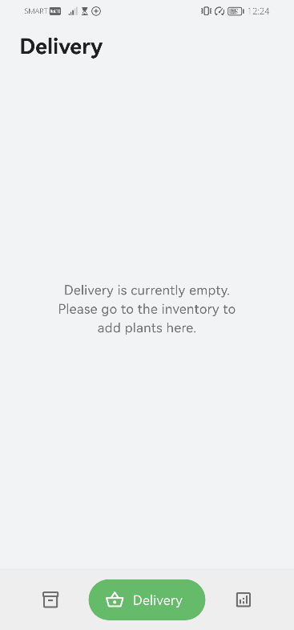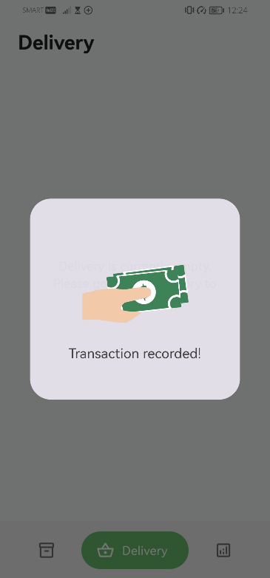

Tapping the plant tile displays the delivery information, and pressing the "sold" button adds the plant to the sales reports section.

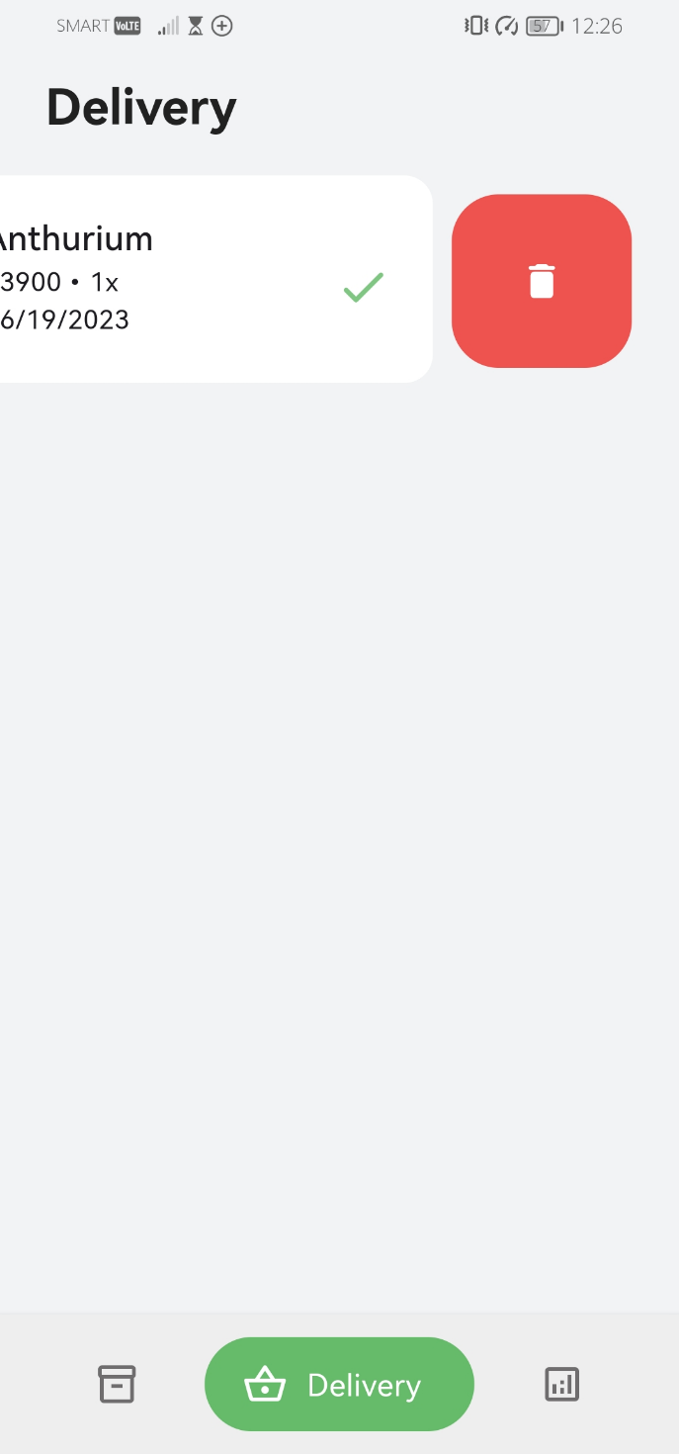

Removing the plant from the delivery is as simple as sliding the plant tile and tapping the delete button. This action also restores the quantity of that plant back to the inventory.

1. 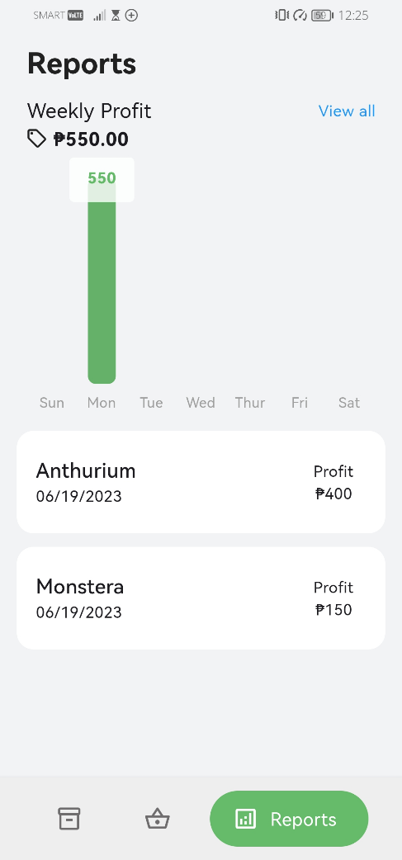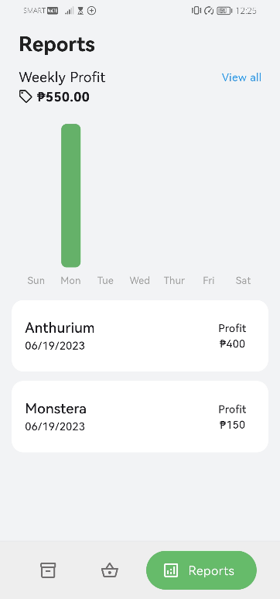Review sales report

Tapping a specific bar in the week will display a tooltip showing the total profit amount for that day.

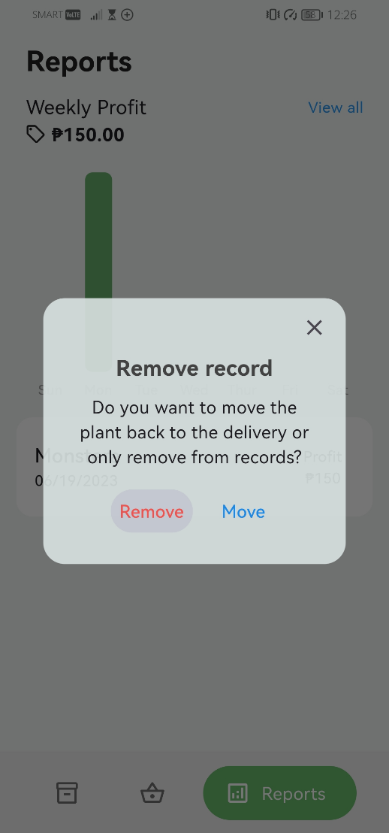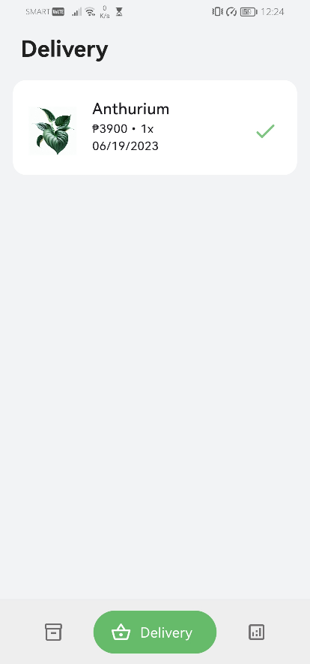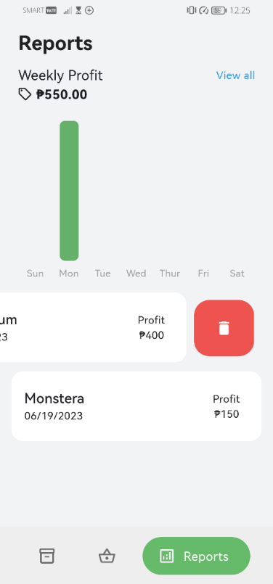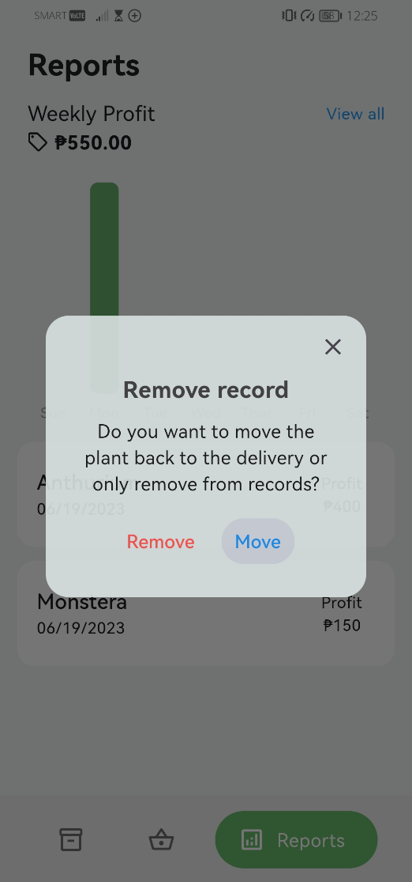

Displaying back the plant in the delivery

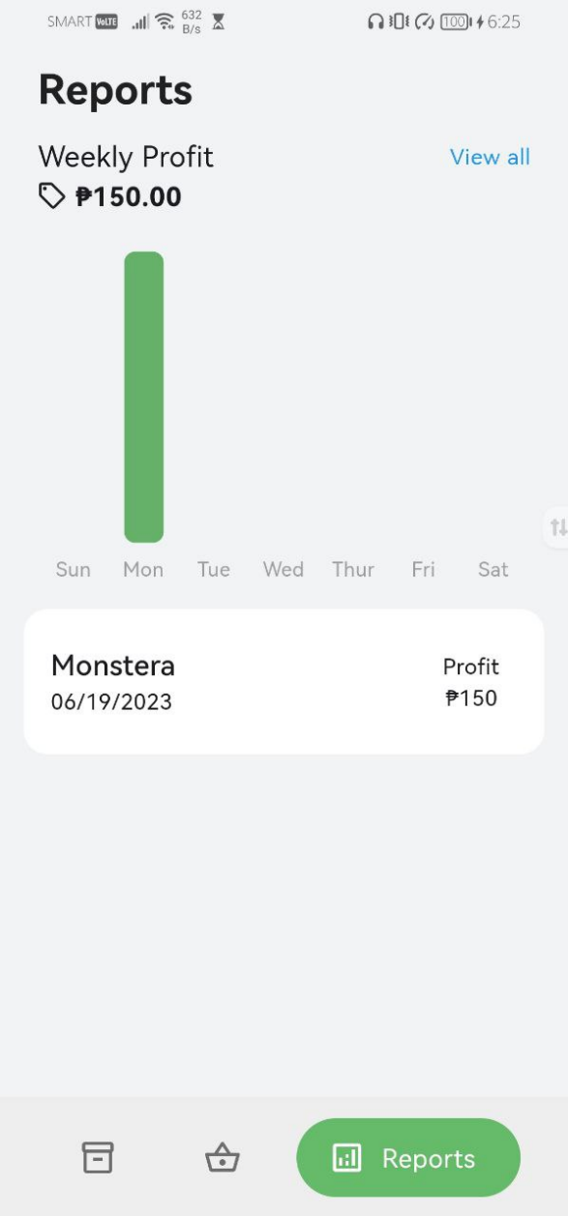

Moving or removing the plant in the reports will decrement the profit amount for that day.

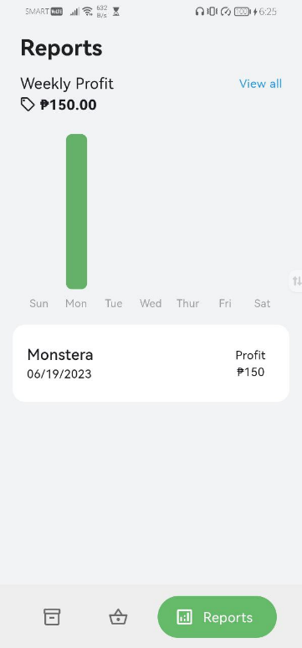

Removed permanently from the reports

Tapping the 'View all' text will navigate to the detailed profit summary shown by month. The dot on a specific day indicates a successful transaction.

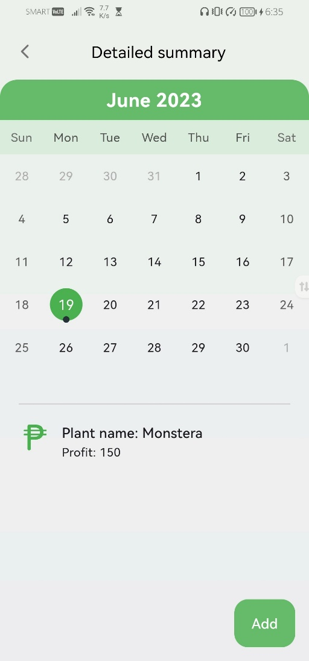

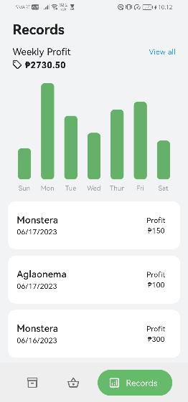

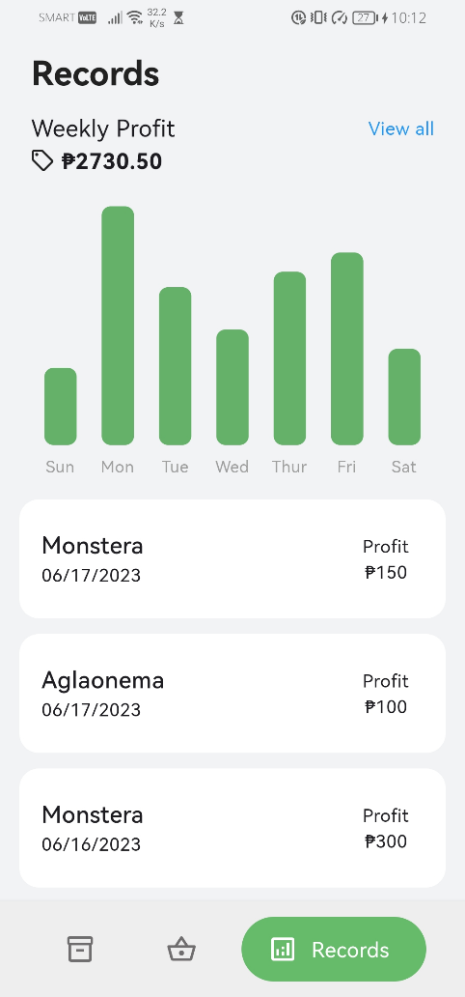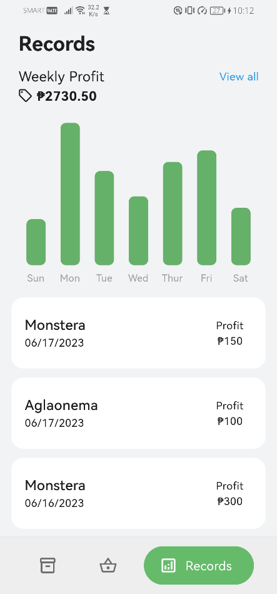

This is how consistent plant business success looks like.

**III. Glossary**

The following are operational definitions of technical terms used within the context of this app:

**Dialog box** **–** allows users to interact with the app by entering information or selecting an action. This appears as a small window that prompts the user for input, displays information, or presents options for the user to choose from.

**Floating action button** **–** the circular icon positioned at the bottom right corner of the inventory. It serves as the primary action button to add a plant to the inventory.

**Plant tile –** a container that displays a condensed view of the plant, showing only essential information.

**Screen –** refers to the user interface display that showcases different aspects and functionalities of the application. It represents the visual area where users interact with the app

**Text field –** an interactive component in the user interface that is specifically designed for users to enter or input data.